|  |  |  |  |  |
| --- | --- | --- | --- | --- |
| SRNO | NAME | DATE | PG NO | SIGN |
| 1 | Initializing Windows Form Using Direct X. | 12/09/22 | 02 |  |
| 2 | Draw Transformed colored Triangle using DirectX. | 12/09/22 | 07 |  |
| 3 | Creating a triangle and texturizing. | 03/10/22 | 12 |  |
| 4 | Lightening (Programmable Diffuse Lightening using direct 3D11). | 03/10/22 | 18 |  |
| 5 | Lightening (Programmable Specular Lightening using direct 3D11). | 20/10/22 | 22 |  |
| 6 | Loading models into Direct X 11 and Rendering. | 24/10/22 | 26 |  |
| 7 | Creating a 2-Dimensional UFO game using unity. | 07/11/22 | 30 |  |
| 8 | Create a 3D Roll a Ball using Unity | 07/11/22 | 61 |  |

PRACTICAL NO:01

# AIM: Initialising Windows Form Using Direct X.

# STEPS:

# 1: Open Visual Studio🡪Create New Project🡪Select Windows Forms App (.Net Framework)🡪Change Name & Location According to You🡪Framework Select : .Net Framework 2.0🡪OK.

# E.g.

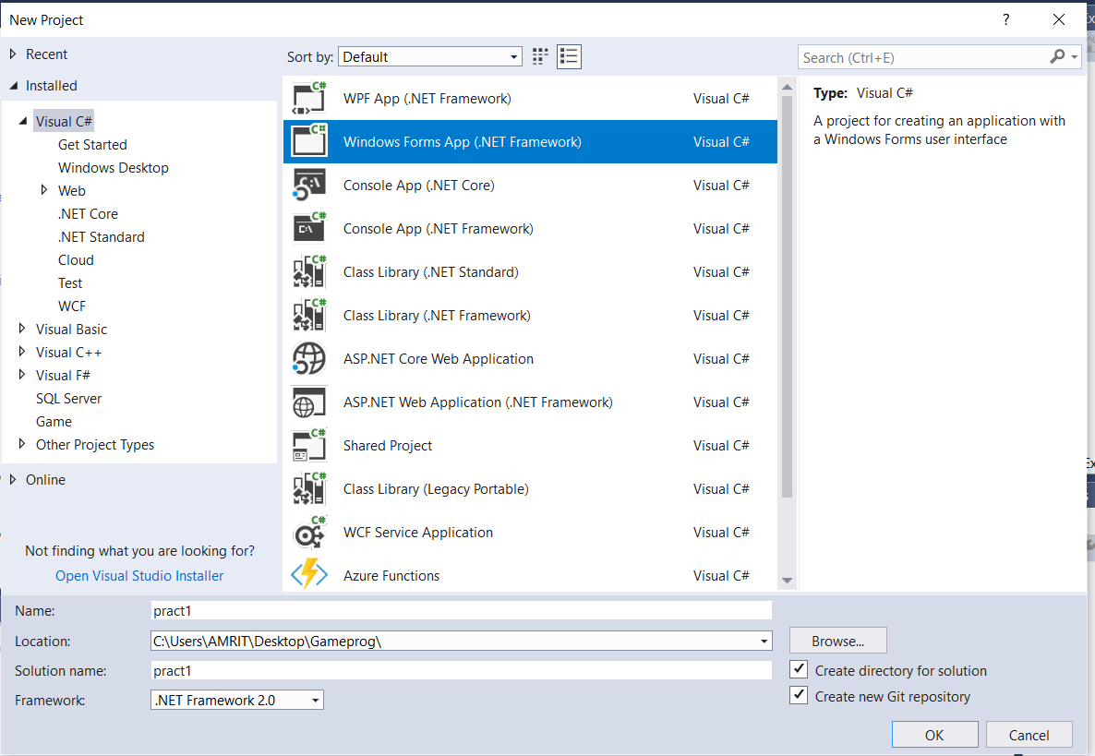

2: Right Click on Name of Your Project In Solution Explorer🡪Click Add🡪References🡪Browse🡪(C:🡪Windows🡪Microsoft.Net🡪DirectX for Managed Code🡪1.0.2902.0🡪ctrl+A🡪Add🡪ok).

3: Right Click on Name of Your Project In Solution Explorer🡪Properties🡪Build🡪Platform Target(change this from Any CPU to x86)🡪ctrl+s.

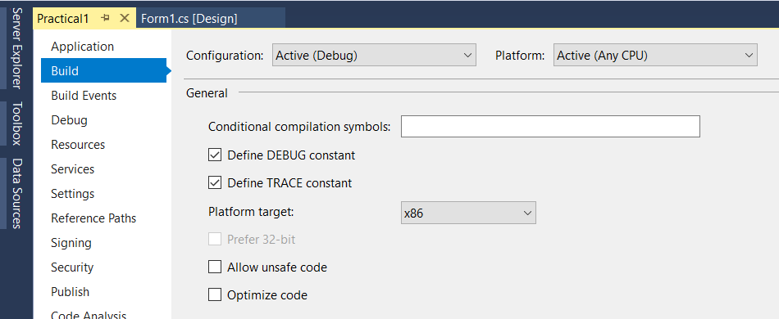

4: Go to Debug🡪windows🡪Exception Setting🡪Managed debugging Assistant🡪uncheck Loderlock.

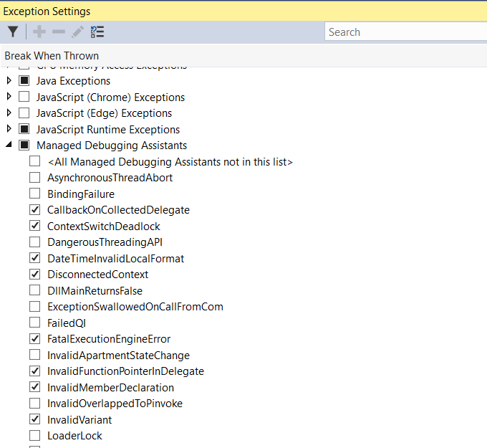

UNCHECK

5: Go To Properties🡪Click on Events🡪Appearance🡪double Click On Paint, A paint Method Is created Automatically.

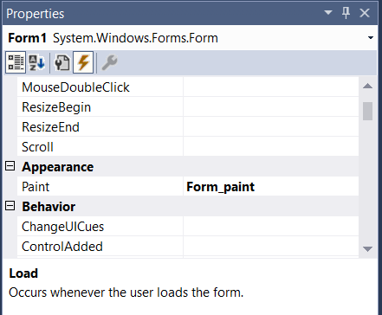

Events

A Simple Program To Initialize Window with DirectX.

Code:

using System;

using System.Collections.Generic;

using System.ComponentModel;

using System.Data;

using System.Drawing;

using System.Linq;

using System.Text;

using System.Threading.Tasks;

using System.Windows.Forms;

using Microsoft.DirectX;

using Microsoft.DirectX.Direct3D;

namespace Practical1

{

public partial class Form1 : Form

{

Microsoft.DirectX.Direct3D.Device device;

public Form1()

{

InitializeComponent();

InitDevice();

}

public void InitDevice()

{

PresentParameters pp = new PresentParameters();

pp.Windowed = true;

pp.SwapEffect = SwapEffect.Discard;

device = new Device(0, DeviceType.Hardware, this, CreateFlags.HardwareVertexProcessing, pp);

}

private void Render()

{

device.Clear(ClearFlags.Target,Color.CornflowerBlue, 0, 1);

device.Present();

}

private void Form1_Load(object sender, EventArgs e)

{

}

private void Form_paint(object sender, PaintEventArgs e)

{

Render();

}

}

}

OUTPUT:-

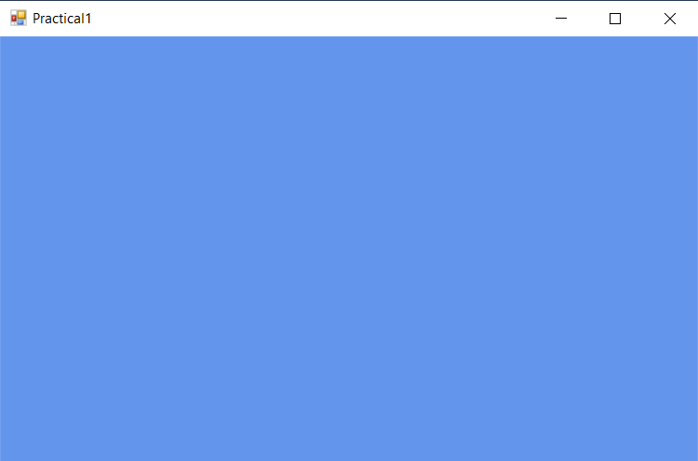

PRACTICAL NO:02

# AIM: Draw Transformed coloured Triangle using DirectX.

# STEPS:

# 1: Open Visual Studio🡪Create New Project🡪Select Windows Forms App (.Net Framework)🡪Change Name & Location According to You🡪Framework Select : .Net Framework 2.0🡪OK.

# E.g.



2: Right Click on Name of Your Project In Solution Explorer🡪Click Add🡪References🡪Browse🡪(C:🡪Windows🡪Microsoft.Net🡪DirectX for Managed Code🡪1.0.2902.0🡪ctrl+A🡪Add🡪ok).

3: Right Click on Name of Your Project In Solution Explorer🡪Properties🡪Build🡪Platform Target(change this from Any CPU to x86)🡪ctrl+s.



4: Go to Debug🡪windows🡪Exception Setting🡪Managed debugging Assistant🡪uncheck Loderlock.



UNCHECK

5: Go To Properties🡪Click on Events🡪Appearance🡪double Click On Paint, A paint Method Is created Automatically.



Events

# CODE:

using System;

using System.Collections.Generic;

using System.ComponentModel;

using System.Data;

using System.Drawing;

using System.Text;

using System.Windows.Forms;

using Microsoft.DirectX;

using Microsoft.DirectX.Direct3D;

namespace trianglepract2

{

public partial class Form1 : Form

{

Microsoft.DirectX.Direct3D.Device device;

public Form1()

{

InitializeComponent();

InitDevice();

}

private void InitDevice()

{

PresentParameters pp = new PresentParameters();

pp.Windowed = true;

pp.SwapEffect = SwapEffect.Discard;

device = new Device(0, DeviceType.Hardware, this, CreateFlags.HardwareVertexProcessing, pp);

}

public void Render()

{

CustomVertex.TransformedColored[] vertexes = new CustomVertex.TransformedColored[3];

vertexes[0].Position = new Vector4(100, 100, 0, 1.0f);//first point

vertexes[0].Color = System.Drawing.Color.FromArgb(0, 255, 0).ToArgb();

vertexes[1].Position = new Vector4(153, 300, 0, 1.0f);//second point

vertexes[1].Color = System.Drawing.Color.FromArgb(0, 0, 255).ToArgb();

vertexes[2].Position = new Vector4(80, 300, 0, 1.0f);//third point

vertexes[2].Color = System.Drawing.Color.FromArgb(255, 0, 0).ToArgb();

device.Clear(ClearFlags.Target, Color.Blue, 0, 1);

device.BeginScene();

device.VertexFormat = CustomVertex.TransformedColored.Format;

device.DrawUserPrimitives(PrimitiveType.TriangleList, 1, vertexes);

device.EndScene();

device.Present();

}

private void Form1_Load(object sender, EventArgs e)

{

}

private void Form1_Paint(object sender, PaintEventArgs e)

{

Render();

}

}

}

# OUTPUT:

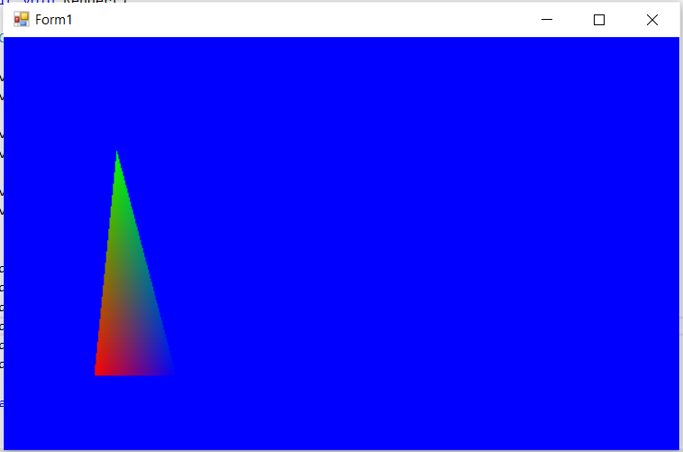

**PRACTICAL NO:03**

**AIM:** Texturing (Texture the Triangle using Direct 3D 11)

# STEPS:

# 1: Open Visual Studio🡪Create New Project🡪Select Windows Forms App (.Net Framework)🡪Change Name & Location According to You🡪Framework Select : .Net Framework 2.0🡪OK.

# E.g.

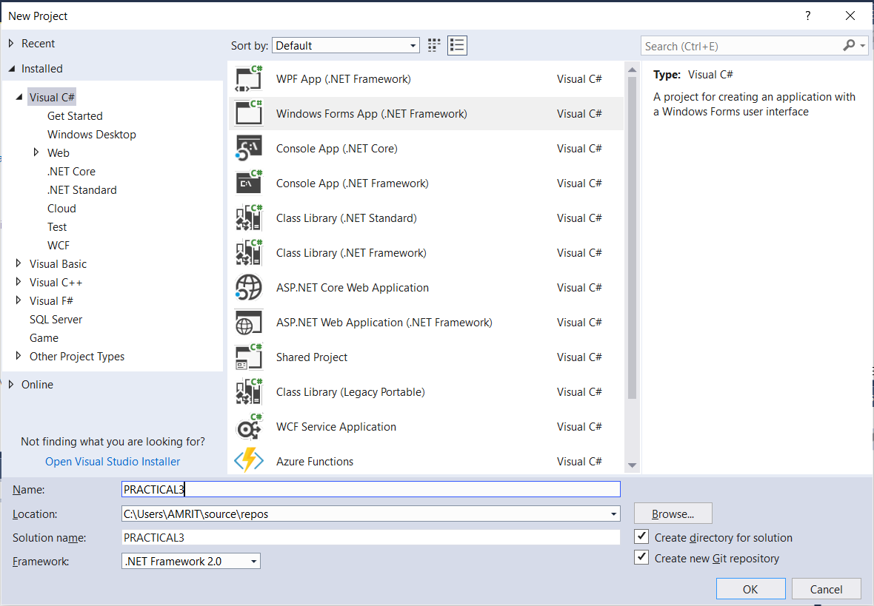

2: Right Click on Name of Your Project In Solution Explorer🡪Click Add🡪References🡪Browse🡪(C:🡪Windows🡪Microsoft.Net🡪DirectX for Managed Code🡪1.0.2902.0🡪ctrl+A🡪Add🡪ok).

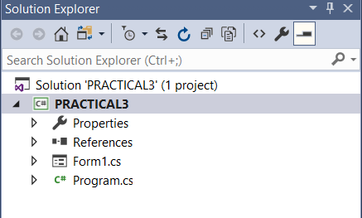

RIGHT CLICK

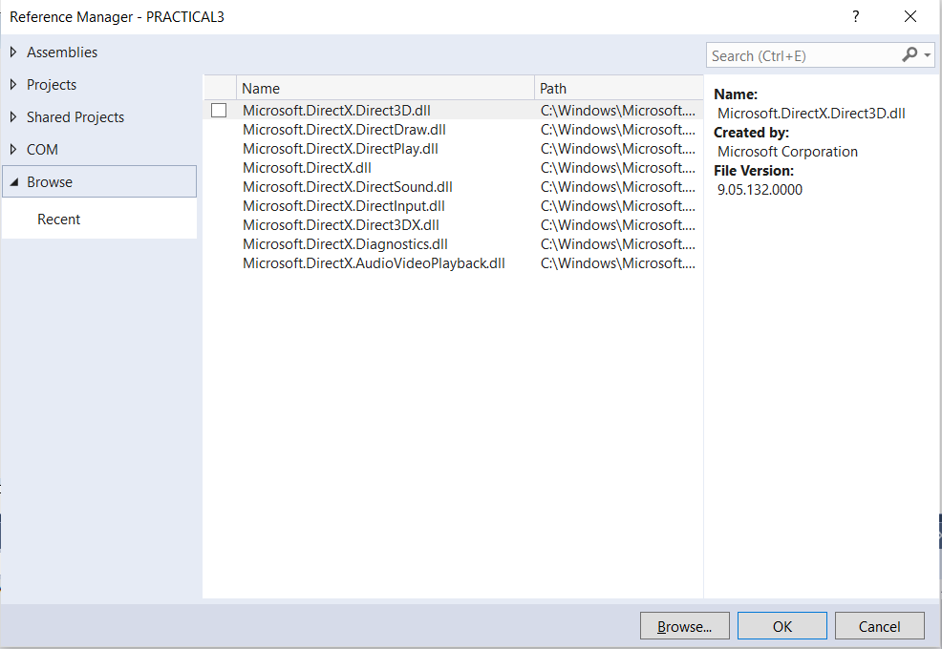

PUT PATH SPECIFIED & then click OK

3: Right Click on Name of Your Project In Solution Explorer🡪Properties🡪Build🡪Platform Target(change this from Any CPU to x86)🡪ctrl+s.



4: Go to Debug🡪windows🡪Exception Setting🡪Managed debugging Assistant🡪uncheck Loderlock.



UNCHECK

5: Go To Properties🡪Click on Events🡪Appearance🡪double Click On Paint, A paint Method Is created Automatically.



Events

6: Go To Browser🡪Type Texture Images🡪Select Any Texture Image Of Your Choice🡪Save the image in following way🡪(save🡪Select Your Project Folder (Practical3)🡪Practical3🡪Now create A New Folder name it As Image🡪inside this Folder Save Your Texture Image)

7.Now in Visual Studio Go To File🡪Open🡪Folder🡪now From this go to the Folder (Image) where You have Saved Your Texture Image🡪copy The Path and Paste it in texture = new Texture (device, newBitmap(@"C:\Users\AMRIT\Desktop\Gameprog\practical3\practical3\images\texture.jpg"), 0, Pool.Managed);

8.Add @Symbol at Beginning of path or else Add ’’\\’’ in path

**CODE:**

using System;

using System.Collections.Generic;

using System.ComponentModel;

using System.Data;

using System.Drawing;

using System.Text;

using System.Windows.Forms;

using Microsoft.DirectX;

using Microsoft.DirectX.Direct3D;

namespace practical3

{

public partial class Form1 : Form

{

Microsoft.DirectX.Direct3D.Device device;

private CustomVertex.PositionTextured[] vertex = new CustomVertex.PositionTextured[3];

private Texture texture;

public Form1()

{

InitializeComponent();

InitDevice();

}

private void InitDevice()

{

PresentParameters pp = new PresentParameters();

pp.Windowed = true;

pp.SwapEffect = SwapEffect.Discard;

device = new Device(0, DeviceType.Hardware, this, CreateFlags.HardwareVertexProcessing, pp);

}

public void Render()

{

device.Transform.Projection = Matrix.PerspectiveFovLH(3.14f / 4, device.Viewport.Width / device.Viewport.Height, 1f, 1000f);

device.Transform.View = Matrix.LookAtLH(new Vector3(0, 0, 20), new Vector3(), new Vector3(0, 1, 0));

device.RenderState.Lighting = false;

vertex[0] = new CustomVertex.PositionTextured(new Vector3(0, 1, 1), 0, 0);

vertex[1] = new CustomVertex.PositionTextured(new Vector3(-1, -1, 1), -1, 0);

vertex[2] = new CustomVertex.PositionTextured(new Vector3(1, -1, 1), 0, -1);

texture = new Texture(device, new Bitmap(@"C:\Users\AMRIT\Desktop\Gameprog\practical3\practical3\images\texture.jpg"), 0, Pool.Managed);

device.Clear(ClearFlags.Target, Color.CornflowerBlue, 1, 0);

device.BeginScene();

device.SetTexture(0, texture);

device.VertexFormat = CustomVertex.PositionTextured.Format;

device.DrawUserPrimitives(PrimitiveType.TriangleList, vertex.Length / 3, vertex);

device.EndScene();

device.Present();

}

private void Form1_Paint(object sender, PaintEventArgs e)

{

Render();

}

}

}

**OUTPUT:**

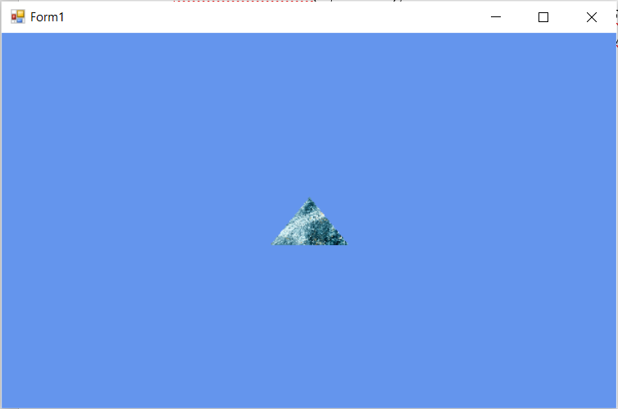

**PRACTICAL NO:04**

**AIM:** Programmable Diffuse Lightening using Direct3D

STEPS:

Open Visual studio: File 🡪 New 🡪 Project 🡪 Visual C# 🡪Select Windows Form application Framework: .Net Framework 2.0

Add References Right Click on References Add references 🡪Browse 🡪 Click on browse button Go to C 🡪 Windows 🡪 Windows.Net 🡪 DirectX for Managed Code 🡪 1.0.2902.0 🡪Select the following .dll files

* Direct 3D.dll(3rd file)
* Direct 3DX.dll(4th file)
* Direct X.dll(Last File)

**CODE:**

using System;

using System.Collections.Generic;

using System.ComponentModel;

using System.Data;

using System.Drawing;

using System.Text;

using System.Windows.Forms;

using Microsoft.DirectX;

using Microsoft.DirectX.Direct3D;

namespace Practicalno4

{

public partial class Form1 : Form

{

Microsoft.DirectX.Direct3D.Device device;

private CustomVertex.PositionNormalColored[] vertex = new CustomVertex.PositionNormalColored[3];

public Form1()

{

InitializeComponent();

InitDevice();

}

private void InitDevice()

{

PresentParameters pp = new PresentParameters();

pp.Windowed = true;

pp.SwapEffect = SwapEffect.Discard;

device = new Device(0, DeviceType.Hardware, this, CreateFlags.HardwareVertexProcessing, pp);

}

public void Render()

{

device.Transform.Projection = Matrix.PerspectiveFovLH(3.14f / 4, device.Viewport.Width / device.Viewport.Height, 1f, 1000f);

device.Transform.View = Matrix.LookAtLH(new Vector3(0, 0, 20), new Vector3(), new Vector3(0, 1, 0));

device.RenderState.Lighting = false;

vertex[0] = new CustomVertex.PositionNormalColored(new Vector3(0, 1, 1), new Vector3(1, 0, 1), Color.Red.ToArgb());

vertex[1] = new CustomVertex.PositionNormalColored(new Vector3(-1, -1, 1), new Vector3(1, 0, 1), Color.Blue.ToArgb());

vertex[2] = new CustomVertex.PositionNormalColored(new Vector3(1, -1, 1), new Vector3(-1, 0, 1), Color.Green.ToArgb());

device.RenderState.Lighting = true;

device.Lights[0].Type = LightType.Directional;

device.Lights[0].Diffuse = Color.Plum;

device.Lights[0].Direction = new Vector3(0.8f, 0, -1);

device.Lights[0].Enabled = true;

device.Clear(ClearFlags.Target, Color.CornflowerBlue, 1, 0);

device.BeginScene();

device.VertexFormat = CustomVertex.PositionNormalColored.Format;

device.DrawUserPrimitives(PrimitiveType.TriangleList, vertex.Length / 3, vertex);

device.EndScene();

device.Present();

}

private void Form1_Paint(object sender, PaintEventArgs e)

{

Render();

}

}

}

**OUTPUT:**

STEPS:

To run the Code: First] Right click on the project 🡪Properties 🡪 Build 🡪Set Platform target to x86 Second] Go to Debug 🡪 Exception Settings 🡪 Expand 🡪Managed Debugging Assistants 🡪 UNCHECK LOADER LOCK Then Run

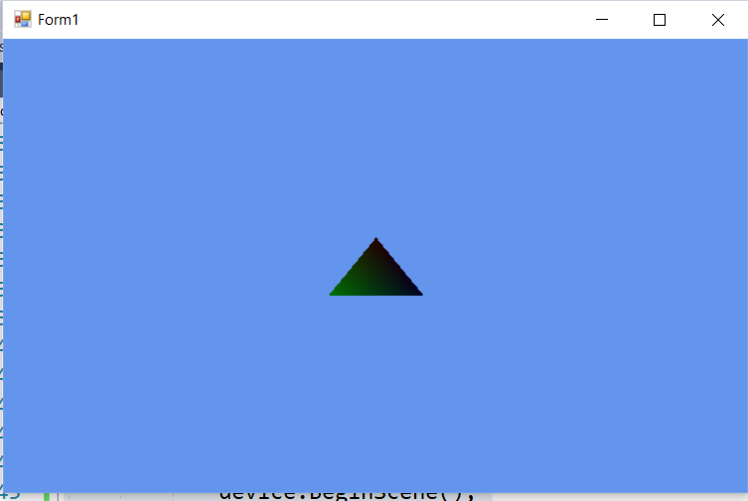

**PRACTICAL NO:05**

# AIM: Lighting (Programmable Specular Lighting using Direct 3D11)

STEPS:

Open Visual studio: File 🡪 New 🡪 Project 🡪 Visual C# 🡪Select Windows Form application Framework: .Net Framework 2.0

Add References Right Click on References Add references 🡪Browse 🡪 Click on browse button Go to C 🡪 Windows 🡪 Windows.Net 🡪 DirectX for Managed Code 🡪 1.0.2902.0 🡪Select the following .dll files

* Direct 3D.dll(3rd file)
* Direct 3DX.dll(4th file)
* Direct X.dll(Last File)

**CODE:**

using System;

using System.Collections.Generic;

using System.ComponentModel;

using System.Data;

using System.Drawing;

using System.Text;

using System.Windows.Forms;

using Microsoft.DirectX;

using Microsoft.DirectX.Direct3D;

namespace practical5

{

public partial class Form1 : Form

{

Microsoft.DirectX.Direct3D.Device device;

private CustomVertex.PositionNormalColored[] vertex = new CustomVertex.PositionNormalColored[3];

public Form1()

{

InitializeComponent();

InitDevice();

}

private void InitDevice()

{

PresentParameters pp = new PresentParameters();

pp.Windowed = true;

pp.SwapEffect = SwapEffect.Discard;

device = new Device(0, DeviceType.Hardware, this, CreateFlags.HardwareVertexProcessing, pp);

}

public void Render()

{

device.Transform.Projection = Matrix.PerspectiveFovLH(3.14f / 4, device.Viewport.Width / device.Viewport.Height, 1f, 1000f);

device.Transform.View = Matrix.LookAtLH(new Vector3(0, 0, 20), new Vector3(), new Vector3(0, 1, 0));

device.RenderState.Lighting = false;

vertex[0] = new CustomVertex.PositionNormalColored(new Vector3(0, 1, 1), new Vector3(1, 0, 1), Color.Red.ToArgb());

vertex[1] = new CustomVertex.PositionNormalColored(new Vector3(-1, -1, 1), new Vector3(1, 0, 1), Color.Blue.ToArgb());

vertex[2] = new CustomVertex.PositionNormalColored(new Vector3(1, -1, 1), new Vector3(-1, 0, 1), Color.Green.ToArgb());

device.RenderState.Lighting = true;

device.Lights[0].Type = LightType.Directional;

device.Lights[0].Specular = Color.DarkGoldenrod;

device.Lights[0].Direction = new Vector3(0.8f, 0, -1);

device.Lights[0].Enabled = true;

device.Clear(ClearFlags.Target, Color.CornflowerBlue, 1, 0);

device.BeginScene();

device.VertexFormat = CustomVertex.PositionNormalColored.Format;

device.DrawUserPrimitives(PrimitiveType.TriangleList, vertex.Length / 3, vertex);

device.EndScene();

device.Present();

}

private void Form1_Paint(object sender, PaintEventArgs e)

{

Render();

}

}

}

**OUTPUT:**

STEPS:

To run the Code: First] Right click on the project 🡪Properties 🡪 Build 🡪Set Platform target to x86 Second] Go to Debug 🡪 Exception Settings 🡪 Expand 🡪Managed Debugging Assistants 🡪 UNCHECK LOADER LOCK Then Run

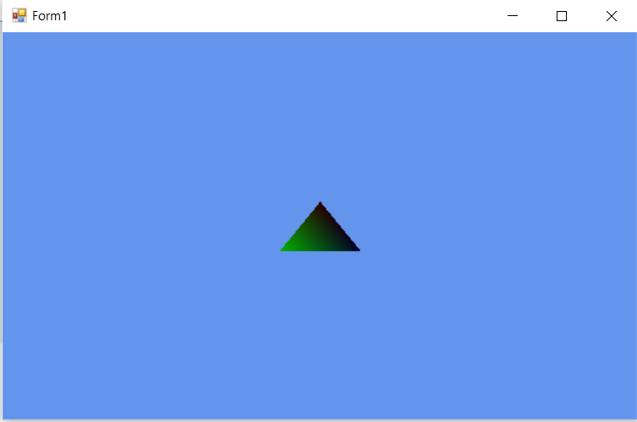

PRACTICAL NO:06

# AIM: Loading models into Direct X 11 and Rendering

STEPS:

Open Visual studio: File 🡪 New 🡪 Project 🡪 Visual C# 🡪Select Windows Form application Framework: .Net Framework 2.0

Add References Right Click on References Add references 🡪Browse 🡪 Click on browse button Go to C 🡪 Windows 🡪 Windows.Net 🡪 DirectX for Managed Code 🡪 1.0.2902.0 🡪Select the following .dll files

* Direct 3D.dll(3rd file)
* Direct 3DX.dll(4th file)
* Direct X.dll(Last File)

# CODE:

using System;

using System.Collections.Generic;

using System.ComponentModel;

using System.Data;

using System.Drawing;

using System.Text;

using System.Windows.Forms;

using Microsoft.DirectX;

using Microsoft.DirectX.Direct3D;

namespace practical6

{

public partial class Form1 : Form

{

Microsoft.DirectX.Direct3D.Device device;

Microsoft.DirectX.Direct3D.Texture texture;

Microsoft.DirectX.Direct3D.Font font;

public Form1()

{

InitializeComponent();

InitDevice();

InitFont();

LoadTexture();

}

private void LoadTexture()

{

texture = new Texture(device, new Bitmap(@"C:\Users\AMRIT\Desktop\Gameprog\practical6\practical6\images\texture.jpg"), 0, Pool.Managed);

}

private void InitFont()

{

System.Drawing.Font f = new System.Drawing.Font("Times New Roman", 16f, FontStyle.Regular);

font = new Microsoft.DirectX.Direct3D.Font(device, f);

}

private void InitDevice()

{

PresentParameters pp = new PresentParameters();

pp.Windowed = true;

pp.SwapEffect = SwapEffect.Discard;

device = new Device(0, DeviceType.Hardware, this, CreateFlags.HardwareVertexProcessing, pp);

}

public void Render()

{

device.Clear(ClearFlags.Target, Color.CornflowerBlue, 0,1);

device.BeginScene();

using (Sprite s = new Sprite(device))

{

s.Begin(SpriteFlags.AlphaBlend);

s.Draw2D(texture, new Rectangle(0, 0, 0, 0), new Rectangle(0, 0, device.Viewport.Width, device.Viewport.Height), new Point(0, 0), 0f, new Point(0, 0), Color.Aqua);

font.DrawText(s, "Game Programming with Direct X tycs", new Point(40, 175), Color.Wheat);

s.End();

}

device.EndScene();

device.Present();

}

private void Form1_Paint(object sender, PaintEventArgs e)

{

Render();

}

private void Form1_Load(object sender, EventArgs e)

{

}

}

# }

# OUTPUT:

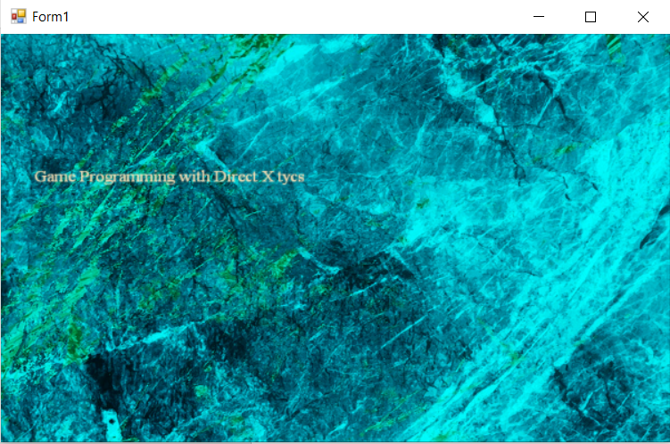

PRACTICAL NO:07

AIM: Creating a 2-Dimensional UFO game using unity.

**STEP 01: Creating new project**

Go to unity hub🡪new🡪select 2D and give appropriate name and path to your project and then click on create

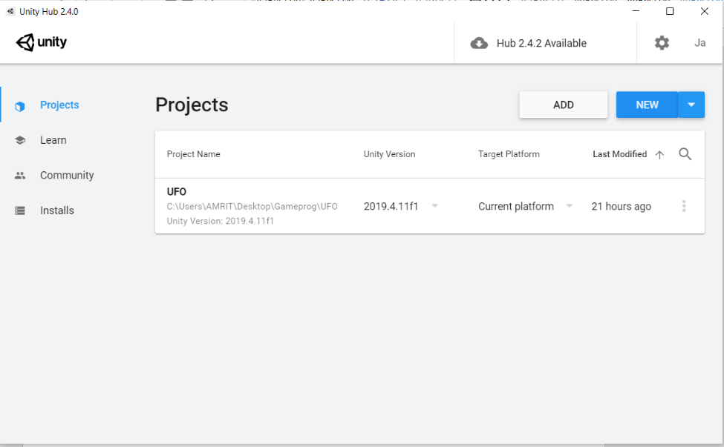

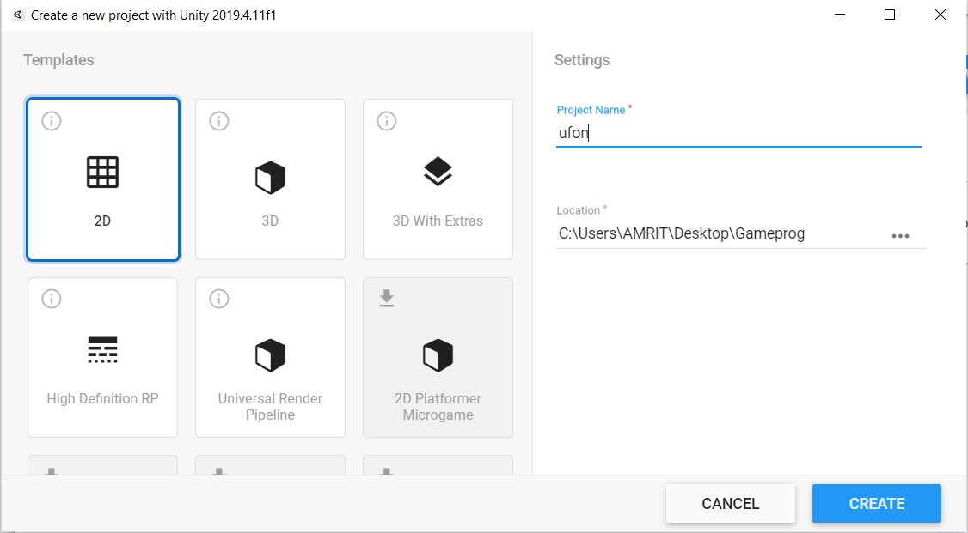

After successfully creating new project with appropriate name this screen will appear.

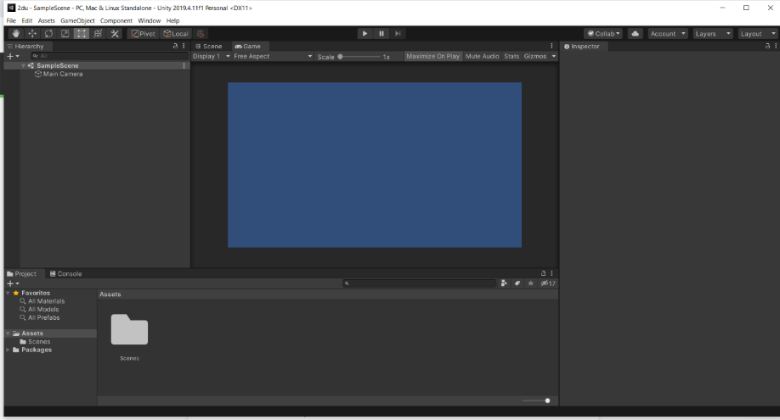

Now we need to import assets from asset store to import asset store go to windows asset store or press ctrl+9.

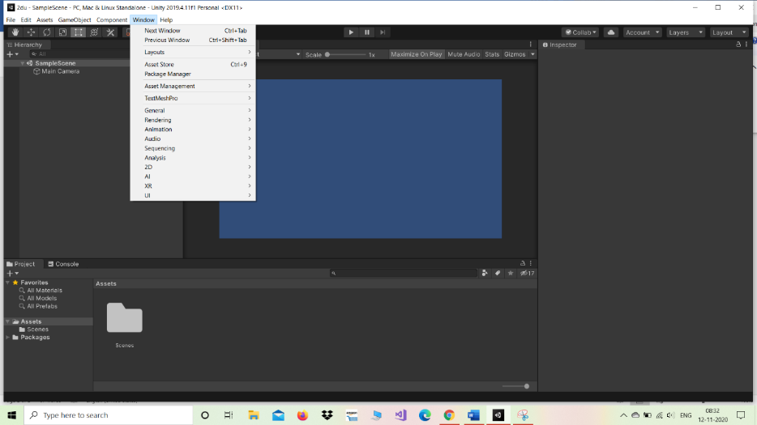

Now in this asset store search for 2d ufo assets.

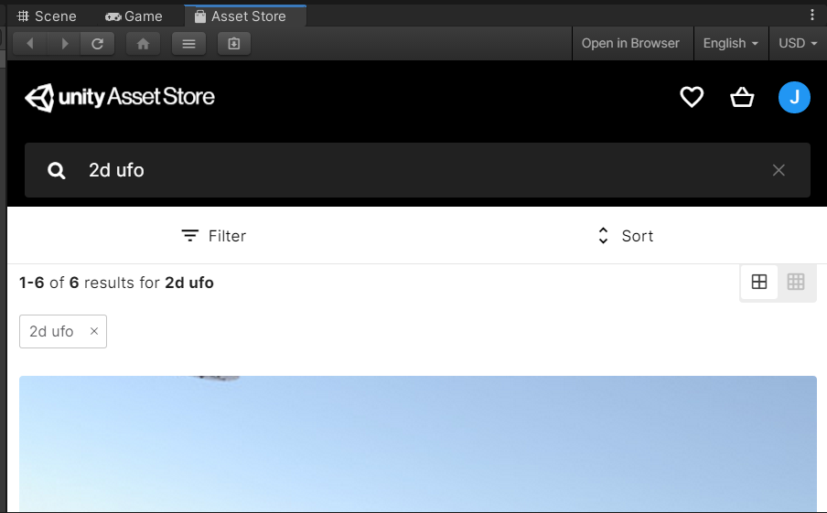

Import this i.e 2d ufo tutorial

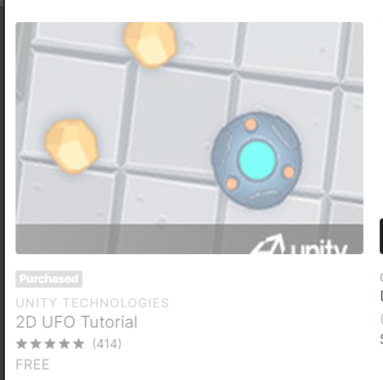

Click import.

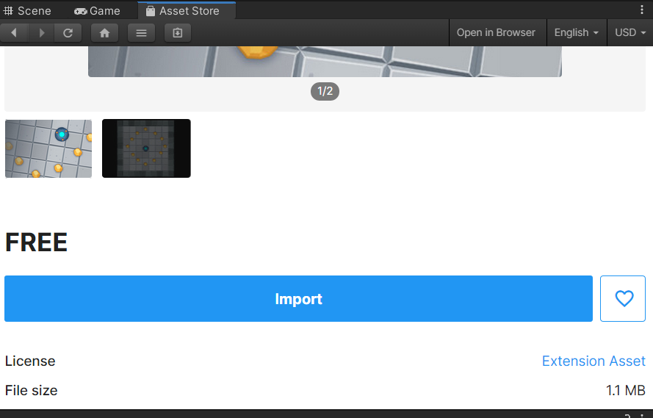

Click import

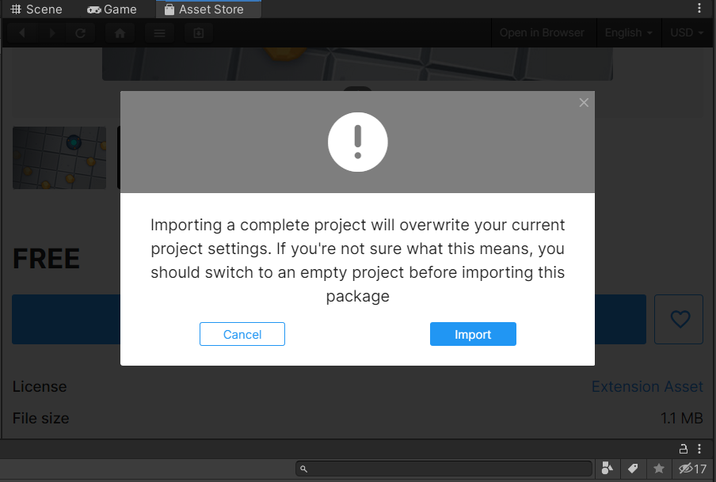

Now do not perform install/upgrade action in that you are going to get error so skip this step.

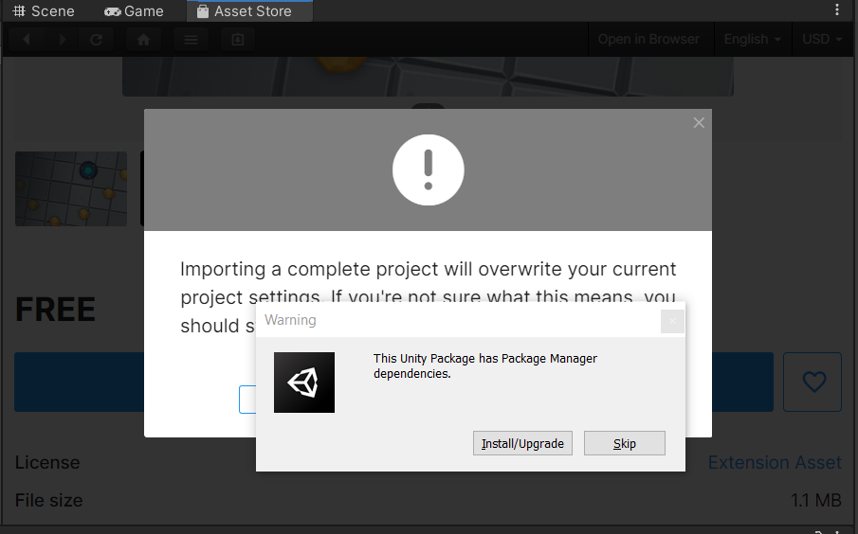

Import all packages.

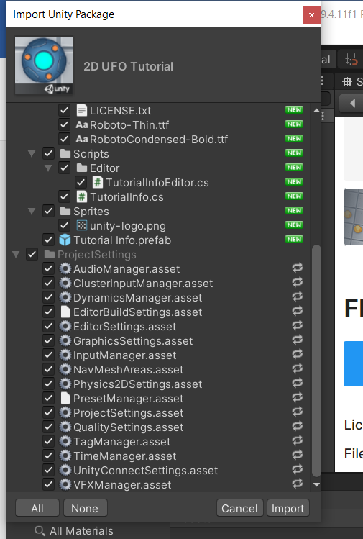

Now you are able to see all the scenes and sprites that are required for creating a 2D ufo game

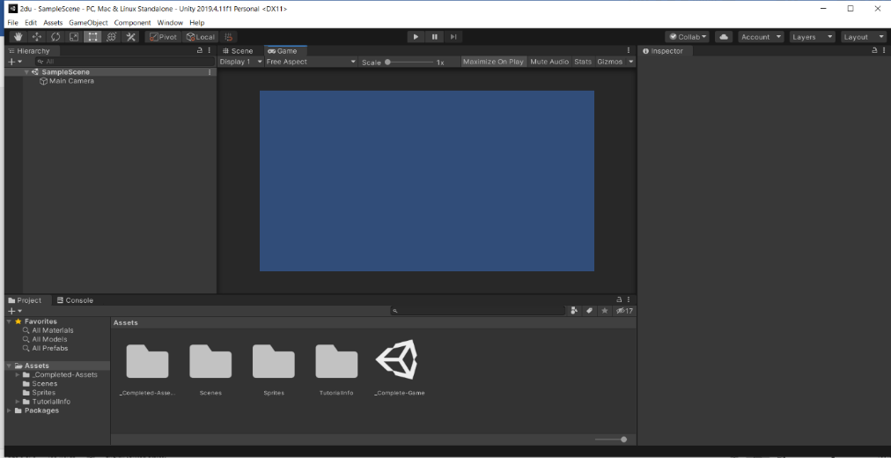

**STEP 02: Setting up the play field**

To create a game board or play field add sprite named background. we can do this by navigating to folder sprite. in sprite we can see a sprite named background. drag background from project view into hierarchy.

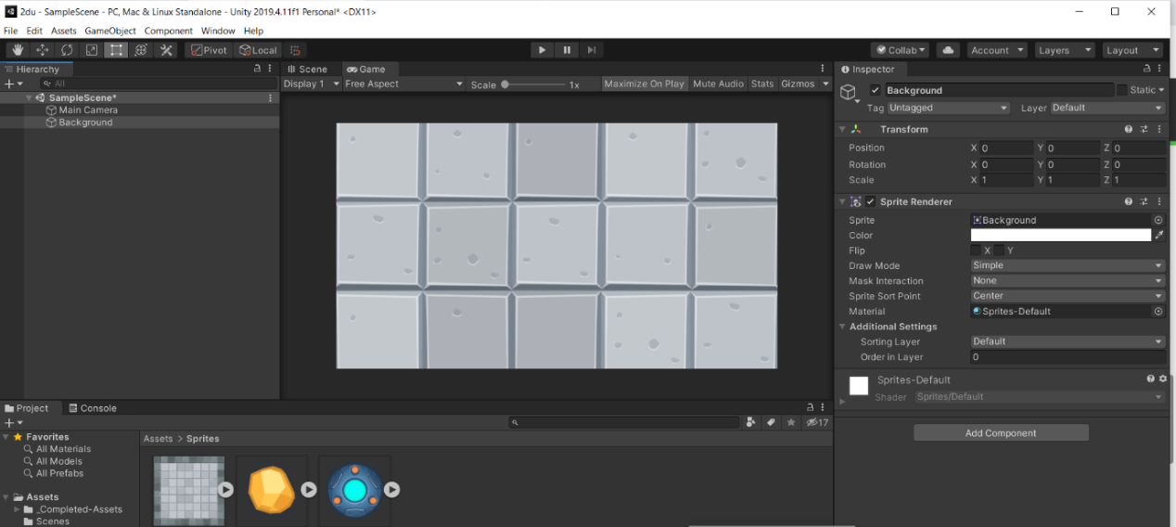

To see the entire game object (Background)keep it selected and press ‘f’ key.

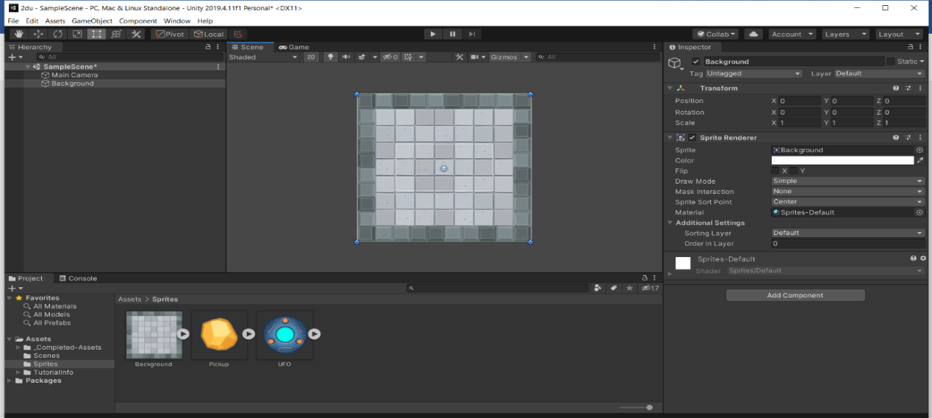

Now drag the UFO sprite into the hierarchy. make sure it comes after background in hierarchy.

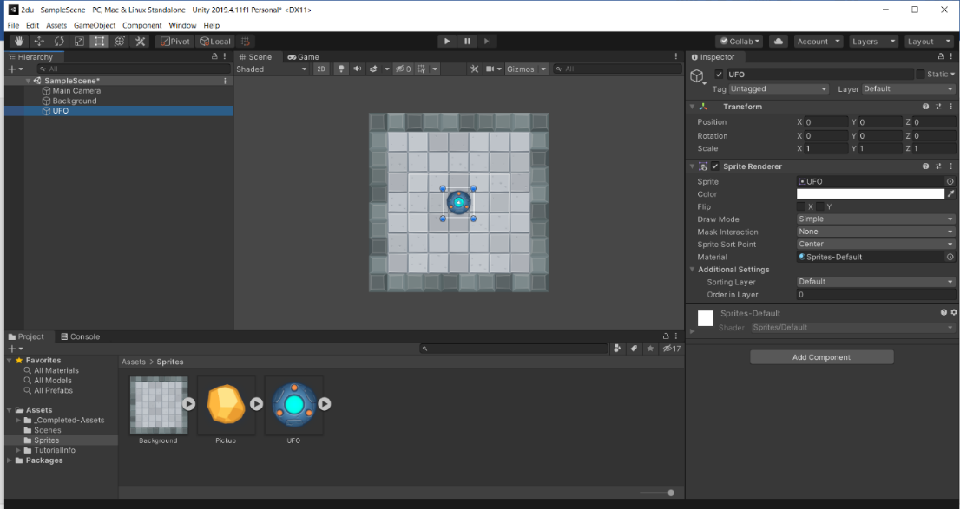

Rename the UFO with Player and make sorting layer to Player from default. also change sorting layer for background from default to background.

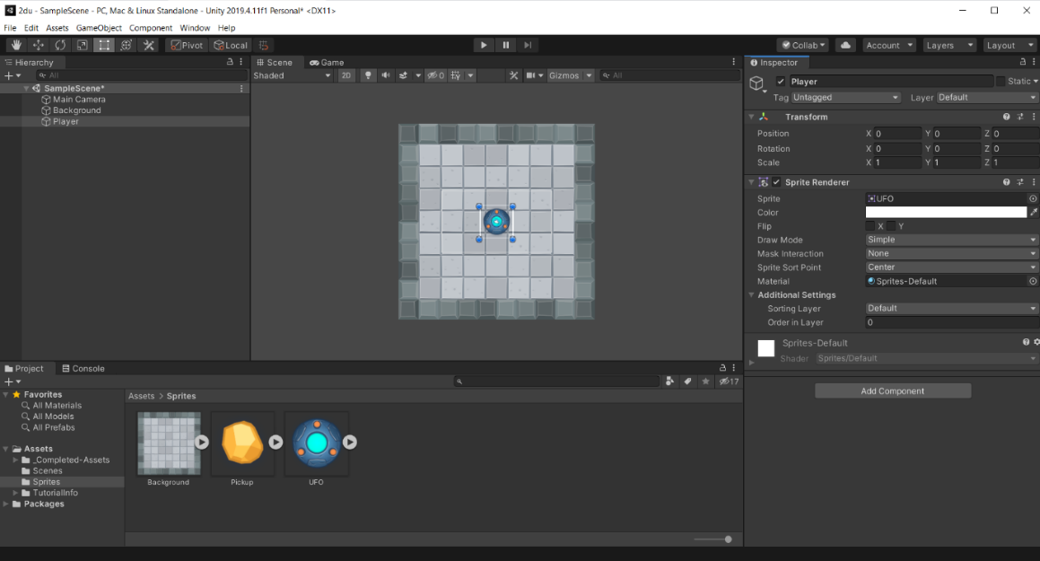

Now resize the Player object by changing scale x and y value to 0.75.

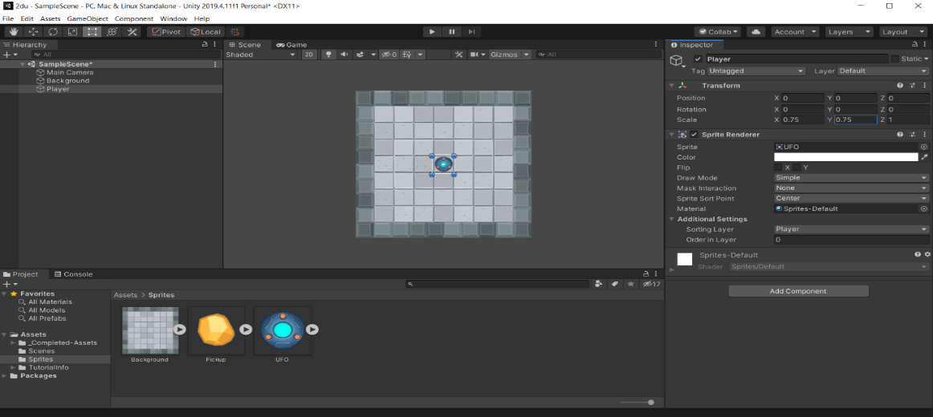

Now from hierarchy select the main camera since the camera view is much tider than original now select the size property and drag it till you are able to see the entire background. And change background color to (32,32,32) this will give a better dark colored background.

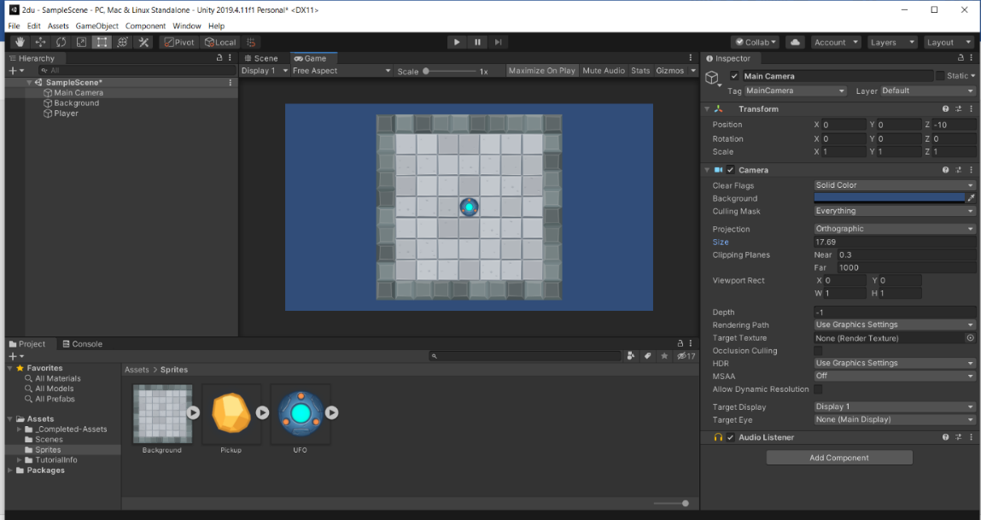 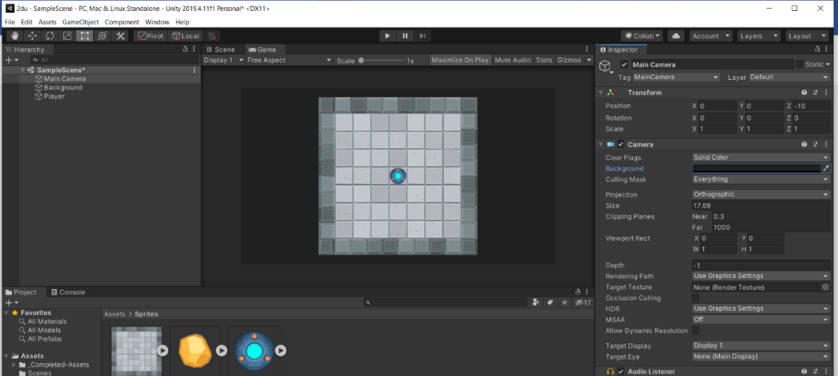

**STEP 03: Controlling the Player**

## **To use physics 2D our game must have rigid body 2D component.to attach new component select the game object (Player) and then go to components menu there select physics 2D then Rigid Body 2D OR directly click on add components in players property then select physics 2D then Rigid Body 2D.**

## **Now we need to attach new C# script in order to make our player (Game Object) move.to create new C# script we can go to assets🡪create🡪c sharp OR you can select the game component (Player) then click on add component then select new script and then give appropriate name to script (PlayerController)**

## **Type the following code inside the script PlayerController**

using System.Collections;

using System.Collections.Generic;

using UnityEngine;

public class PlayerController : MonoBehaviour

{

public float speed; //Floating point variable to store the player's movement speed.

private Rigidbody2D rb2d; //Store a reference to the Rigidbody2D component required to use 2D Physics.

// Use this for initialization

void Start()

{

//Get and store a reference to the Rigidbody2D component so that we can access it.

rb2d = GetComponent<Rigidbody2D>();

}

//FixedUpdate is called at a fixed interval and is independent of frame rate. Put physics code here.

void FixedUpdate()

{

//Store the current horizontal input in the float moveHorizontal.

float moveHorizontal = Input.GetAxis("Horizontal");

//Store the current vertical input in the float moveVertical.

float moveVertical = Input.GetAxis("Vertical");

//Use the two store floats to create a new Vector2 variable movement.

Vector2 movement = new Vector2(moveHorizontal, moveVertical);

//Call the AddForce function of our Rigidbody2D rb2d supplying movement multiplied by speed to move our player.

rb2d.AddForce(movement * speed);

}

}

## **After typing the above code save and exit the script editor and then you will be able to see the option in the properties inside the script component speed give it value of 10 and then make gravity option of rigidbody2D component to 0 then hit play button.**

## 

## **Now you are able to control player now in next step we are going to add colliders to our game since the Player game object can move outside the play area.**

**STEP 04: Adding collisions**

The walls or boundaries do not prevent player to move through them. To add colliders first select the Player game object the click on add components then search for circle collider. Once you add the circle collider to the Player Game Object You will be able to see the circle border around the Player game object. Adjust it radius to some point in which it only covers the Player game object (2.15).

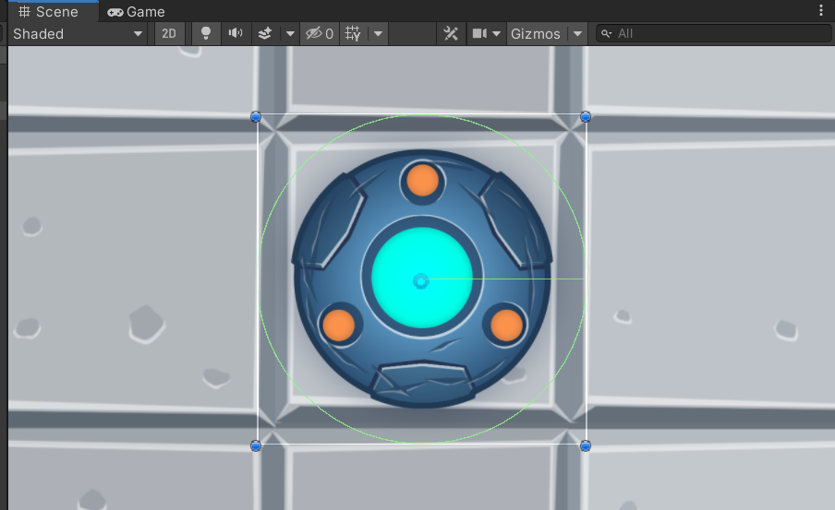

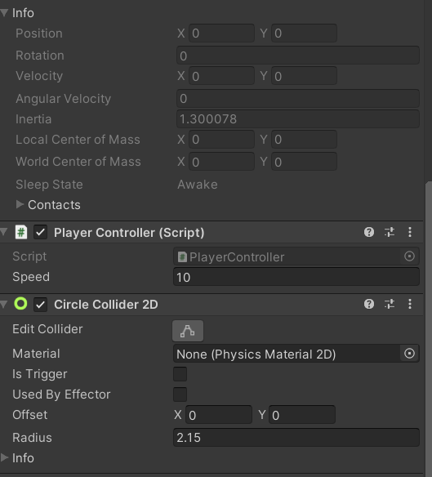

Now with the background object selected click on add components🡪physics 2D🡪box collider 2D.

Change the x offset to 14.3 and size to 3.3.

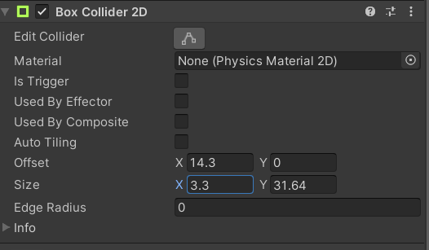

Similarly copy component this component and paste it as new component to create colliders on remaining 3 sides.

The only thing changes is offset and size to create a wall on the opposite side of the one already created just add -ve sign in front of x offset value (-14.3)

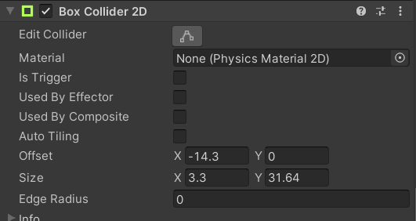

Now to create the remaining colliders swap x and y offset and size values

i.e when x=14.3 & y=0 put y=14.3 & x=0

when x=3.3 & y=31.64 put y=3.3 & x=31.64 see fig(A)

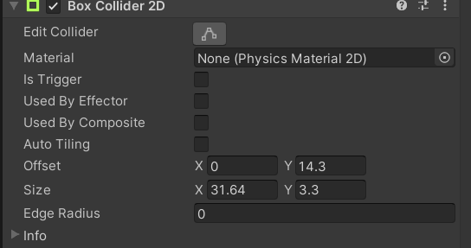 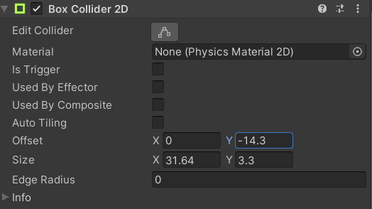

1. (B)

now to create the collider to opposite side of one created just add -ve sign to y offset (-14.3) fig(B).

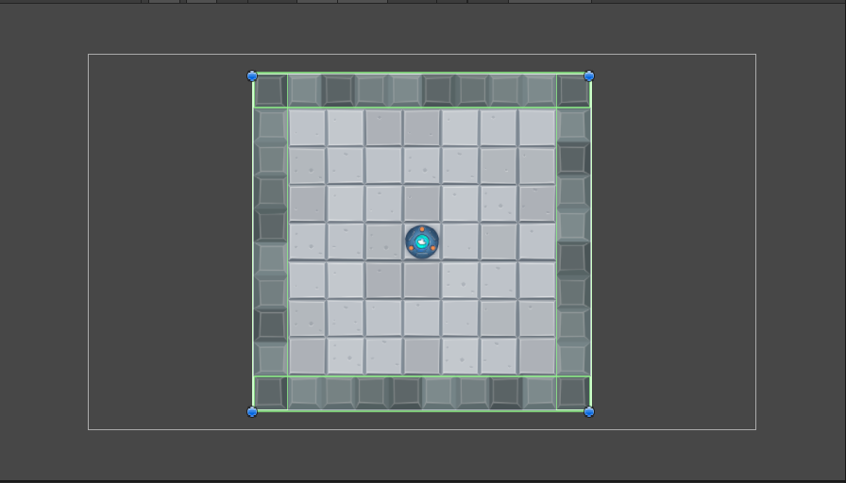

Now you can see green border on all 4 sides of background game object which is box collider which will prevent the Player game object from going outside the play area.

**STEP 05: Camera moving and following the player**

To make camera move along with player select the main camera game object from hierarchy then click on add component the click on new script then give it name camera controller then open the script and type the following code in it.

using System.Collections;

using System.Collections.Generic;

using UnityEngine;

public class CameraController : MonoBehaviour

{

public GameObject player; //Public variable to store a reference to the player game object

private Vector3 offset; //Private variable to store the offset distance between the player and camera

// Use this for initialization

void Start()

{

//Calculate and store the offset value by getting the distance between the player's position and camera's position.

offset = transform.position - player.transform.position;

}

// LateUpdate is called after Update each frame

void LateUpdate()

{

// Set the position of the camera's transform to be the same as the player's, but offset by the calculated offset distance.

transform.position = player.transform.position + offset;

}

}

Now you have to drag the player game object from hierarchy to player in properties of main camera’s script CameraController

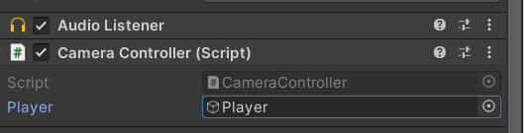

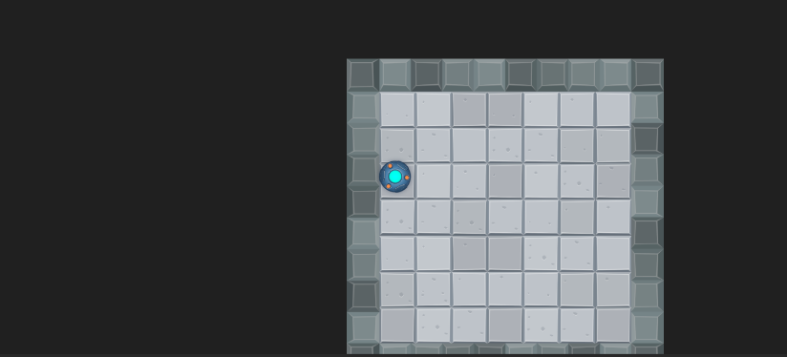

Now you can see that the main camera moves along with player game object

**STEP 06: Creating Collectable Objects**

First select the pickup game object from sprite and drop it into the hierarchy. deactivate the player game object for sometime to work with pickup object. Now select the pickup object and press f key to zoom on to pickup.

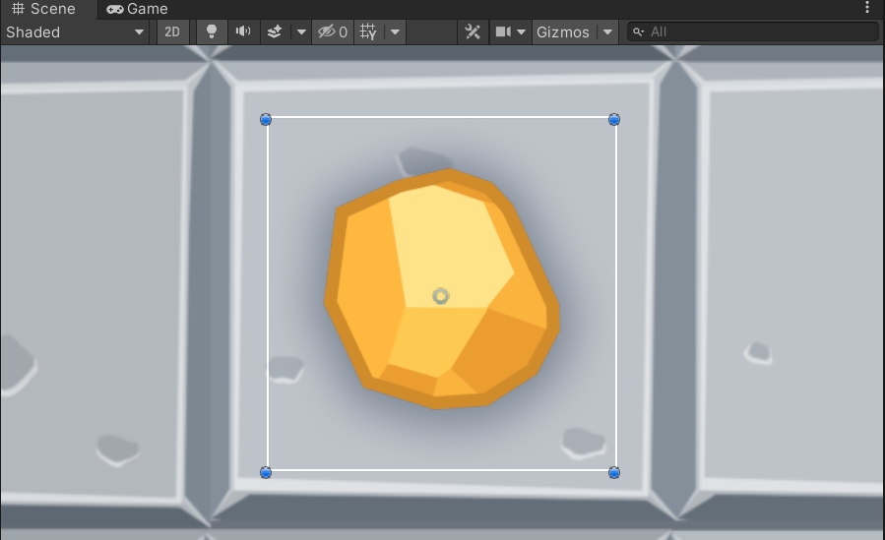

Now click on add components then add circle collider to the pickup game object and change its radius to one which best fits the pickup game object.

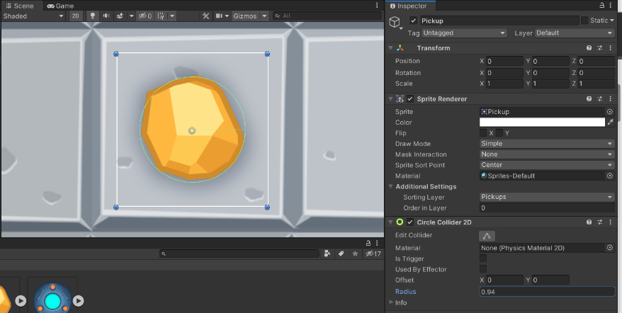

Now we want our pickup to rotate to do this keep the pickup game object selected add new script name it rotator and then click on create and add. After creating it type the following code in to rotator script.

using System.Collections;

using System.Collections.Generic;

using UnityEngine;

public class Rotator : MonoBehaviour

{

//Update is called every frame

void Update()

{

//Rotate thet transform of the game object this is attached to by 45 degrees, taking into account the time elapsed since last frame.

transform.Rotate(new Vector3(0, 0, 45) * Time.deltaTime);

}

}

Now after typing this script you will see that your pickup object starts to rotate.

Now create a new game object and name it as pickups

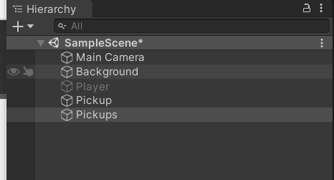

Next drag the pickup game object inside the Pickups game object

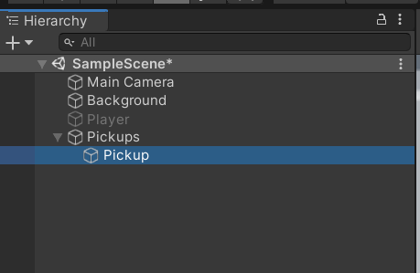

**STEP 07: Picking up the Collectable Objects**

Now to collect the pickup object select the Player Game Object and open the PlayerController Script for editing.

Select all pickup game objects and add tag to pickup

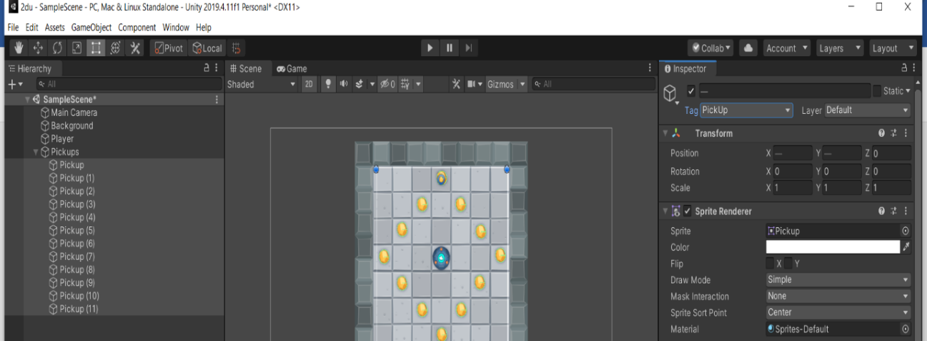

Now add component then click on rigid body 2d then add it to all pickups

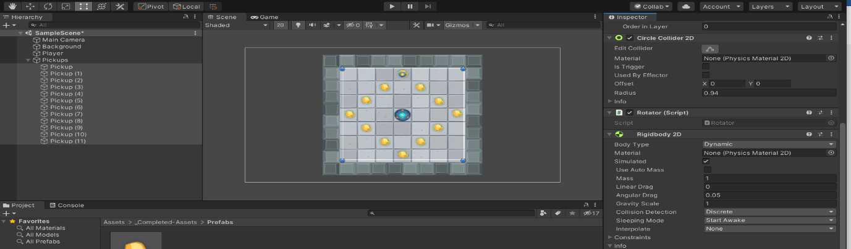

Then change the rigid body 2D component Body type to kinematic.

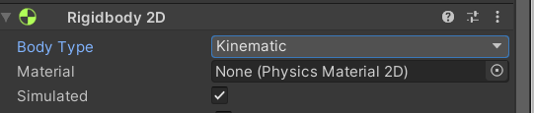

Also in circle collider 2D property of all pickup make is trigger selected

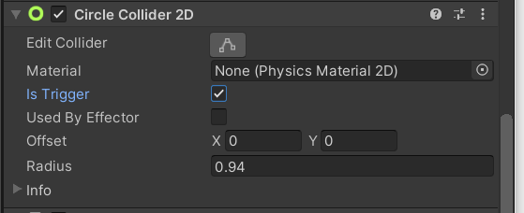

**STEP 08: Picking up the Collectable Objects**

Now we need a tool to store the value of our counted collectable

Now select the player game object and open the PlayerController Script for editing/updating

And do these changes

using System.Collections;

using System.Collections.Generic;

using UnityEngine;

using UnityEngine.UI;

public class PlayerController : MonoBehaviour

{

public float speed; //Floating point variable to store the player's movement speed.

public Text countText; //Store a reference to the UI Text component which will display the number of pickups collected.

public Text winText; //Store a reference to the UI Text component which will display the 'You win' message.

private Rigidbody2D rb2d; //Store a reference to the Rigidbody2D component required to use 2D Physics.

private int count; //Integer to store the number of pickups collected so far.

// Use this for initialization

void Start()

{

//Get and store a reference to the Rigidbody2D component so that we can access it.

rb2d = GetComponent<Rigidbody2D>();

//Initialize count to zero.

count = 0;

//Initialze winText to a blank string since we haven't won yet at beginning.

winText.text = "";

//Call our SetCountText function which will update the text with the current value for count.

SetCountText();

}

//FixedUpdate is called at a fixed interval and is independent of frame rate. Put physics code here.

void FixedUpdate()

{

//Store the current horizontal input in the float moveHorizontal.

float moveHorizontal = Input.GetAxis("Horizontal");

//Store the current vertical input in the float moveVertical.

float moveVertical = Input.GetAxis("Vertical");

//Use the two store floats to create a new Vector2 variable movement.

Vector2 movement = new Vector2(moveHorizontal, moveVertical);

//Call the AddForce function of our Rigidbody2D rb2d supplying movement multiplied by speed to move our player.

rb2d.AddForce(movement * speed);

}

//OnTriggerEnter2D is called whenever this object overlaps with a trigger collider.

void OnTriggerEnter2D(Collider2D other)

{

//Check the provided Collider2D parameter other to see if it is tagged "PickUp", if it is...

if (other.gameObject.CompareTag("PickUp"))

//... then set the other object we just collided with to inactive.

other.gameObject.SetActive(false);

//Add one to the current value of our count variable.

count = count + 1;

//Update the currently displayed count by calling the SetCountText function.

SetCountText();

}

//This function updates the text displaying the number of objects we've collected and displays our victory message if we've collected all of them.

void SetCountText()

{

//Set the text property of our our countText object to "Count: " followed by the number stored in our count variable.

countText.text = "Count: " + count.ToString();

//Check if we've collected all 12 pickups. If we have...

if (count >= 12)

//... then set the text property of our winText object to "You win!"

winText.text = "You win!";

}

}

Now we can Store and increment our count but we have no way of displaying it. To display the text, we will be using the unities user interface (UI) toolset. First create a new UI text element from hierarchy’s create menu. keep the Player game object selected then in hierarchy then click on (+) sign then select UI then Text. you can see a new game object named canvas is created with Text game object inside it. All UI elements must be child of canvas to work properly.

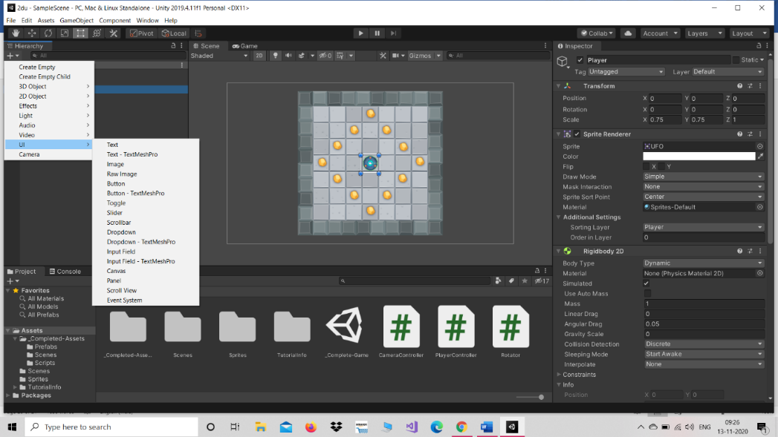

Now we rename the Text game object to CountText .

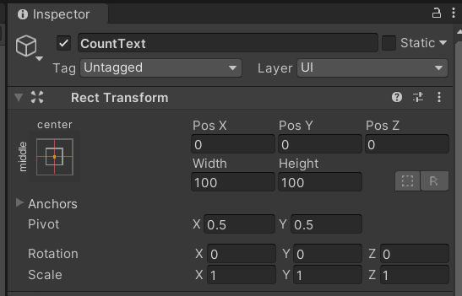

With CountText still highlighted press ‘f’ key.

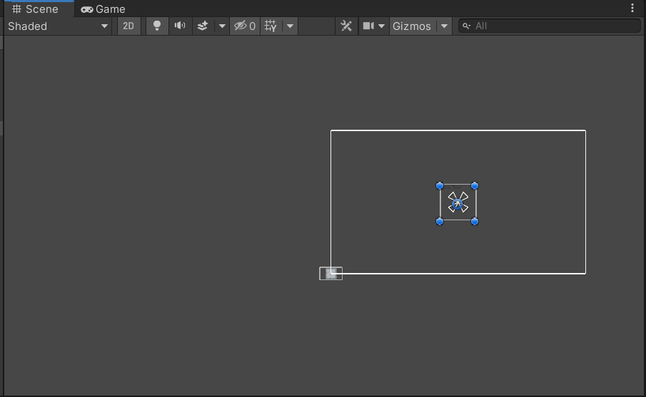

Now change the colour (255,255,0) of the text and give some placeholder text (Count Text).

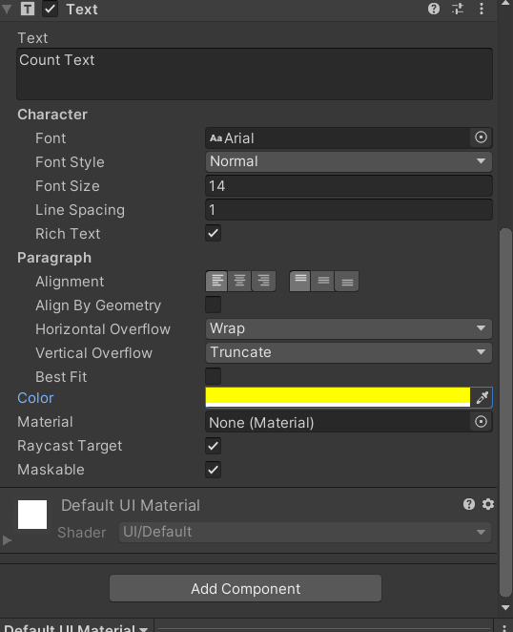

Now to anchor the text to the top left corner we change the anchor property of rect transform.

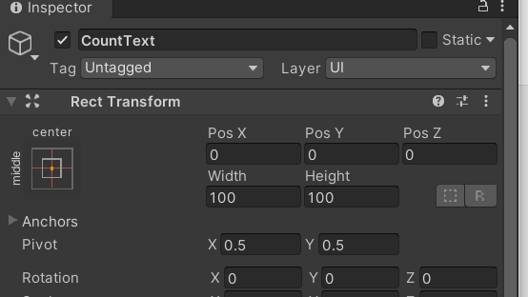

Open the anchors and preset menu by clicking on button displaying the current anchor preset

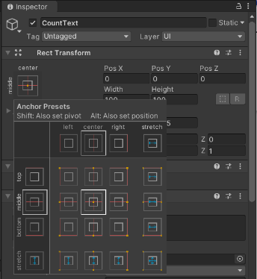

Hold the shift and alt key and select the top left position.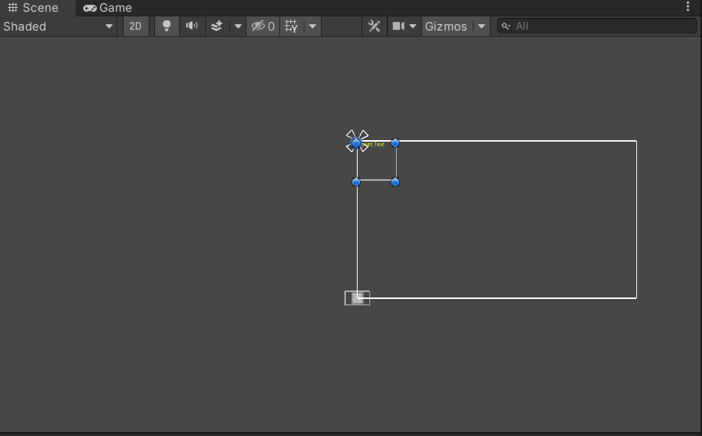

**Add some space by changing pos x and pos y by some value.**

## 

## **Our player controller script has 2 new text properties. We can associate a reference to CountText and WinText by simply dragging them from hierarchy to the PlayerController Script object associated with it.**

## 

**STEP 09: Building our 2D UFO game**

Now to build our game open the build setting from file menu.

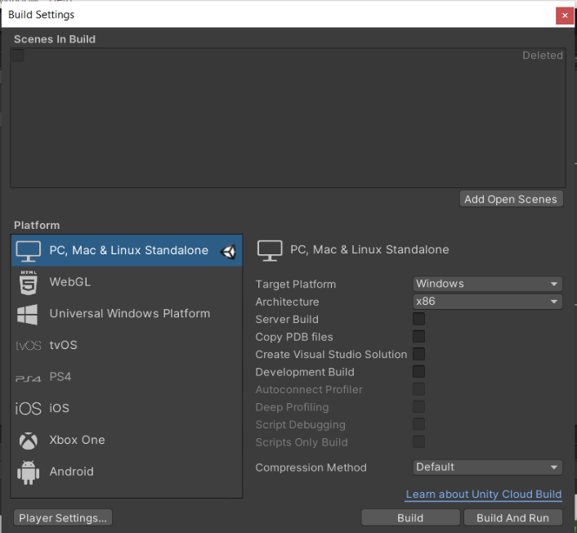

Now we can add current scene either by clicking on add open scenes or we can go to scenes and then drag and drop it on the scenes in Build.

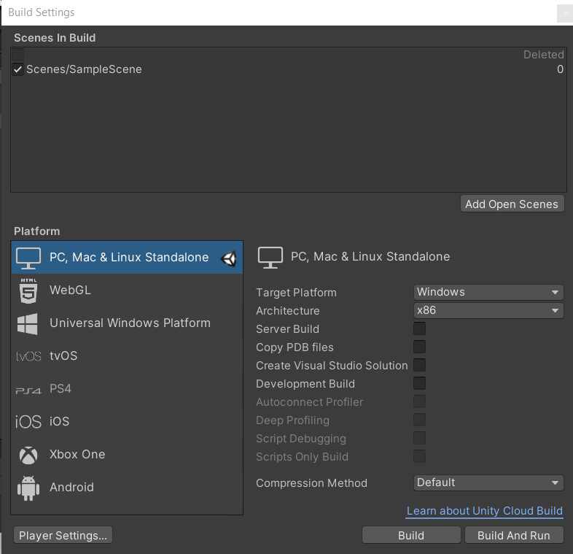

now click on build button. now here create a new folder named builds.this folder should be placed in between the asset and library folder’s.

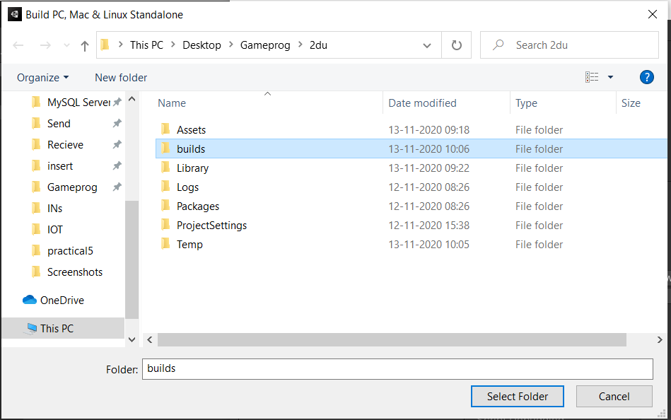

Within the build folder create a new folder named UFO game build 1.

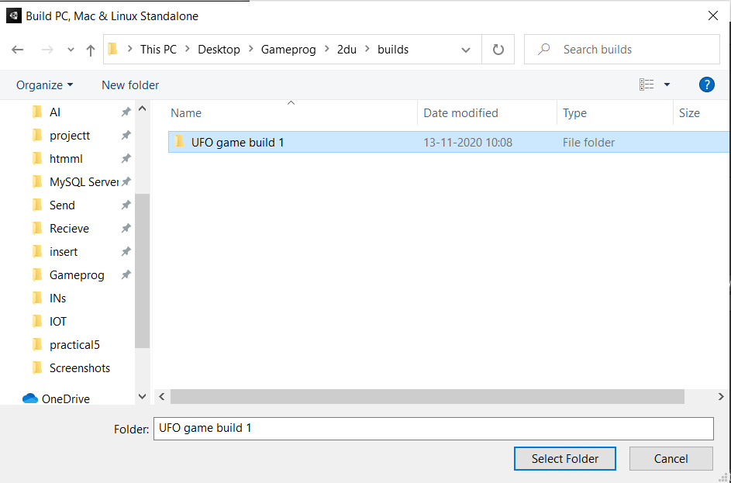

And click on select folder. Unity will now build the application and save it in this folder.

Now run the game.

OUTPUT:



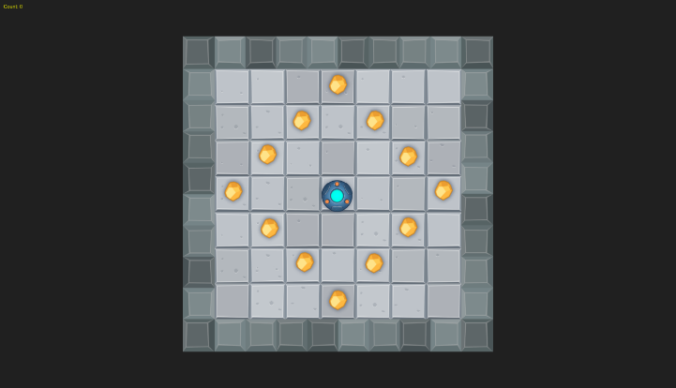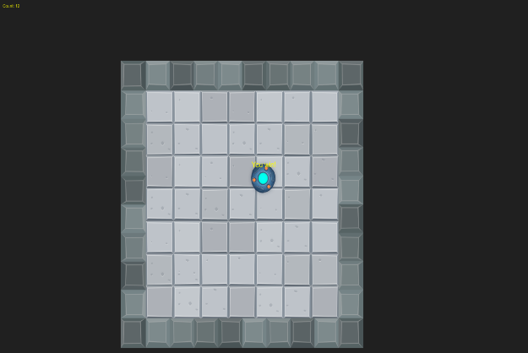

PRACTICAL NO:08

AIM: Create a 3D Roll a Ball using Unity

**STEP 01: Setting up the Game**

Creating a new project click on new🡪give appropriate name to your project🡪select 3D🡪give appropriate path where you want your game to be stored and click on create.

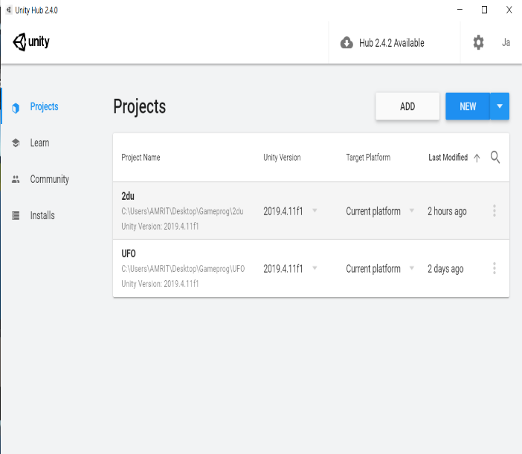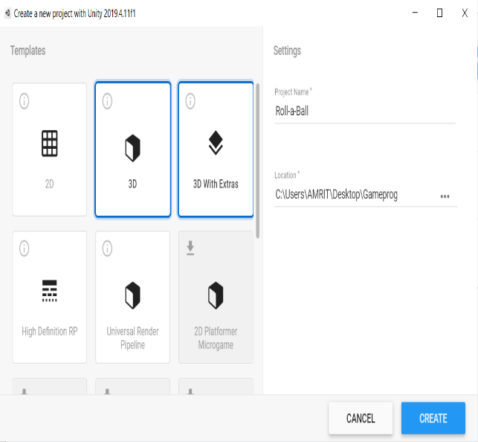

After successfully creating new project with appropriate name and path this screen will appear

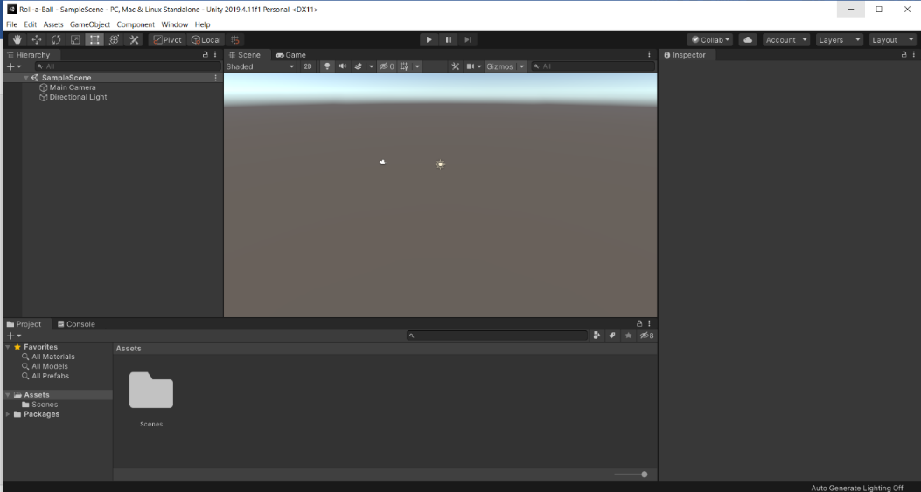

Now we will create a game board or playfield. To create these, we will use the stock unity plane. we can create this plane either by going to

GameObject menu🡪 3D object🡪plane.

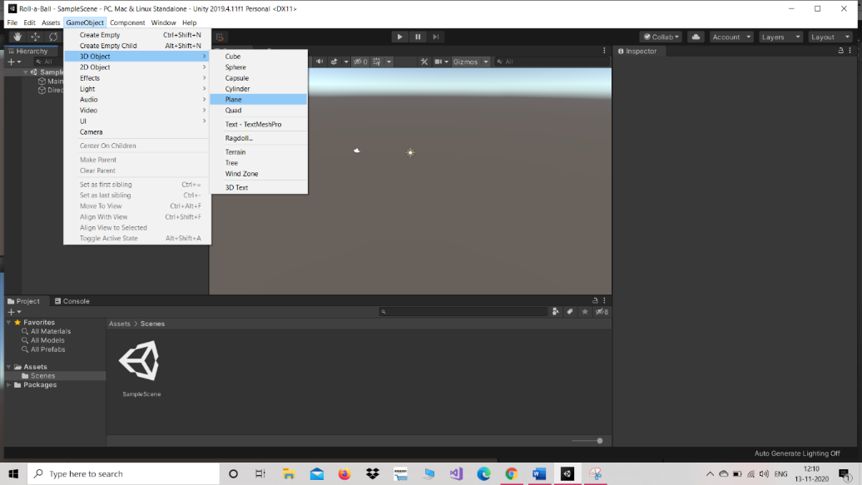

OR

inside the Hierarchy click on (+) sign🡪3D-object🡪plane.

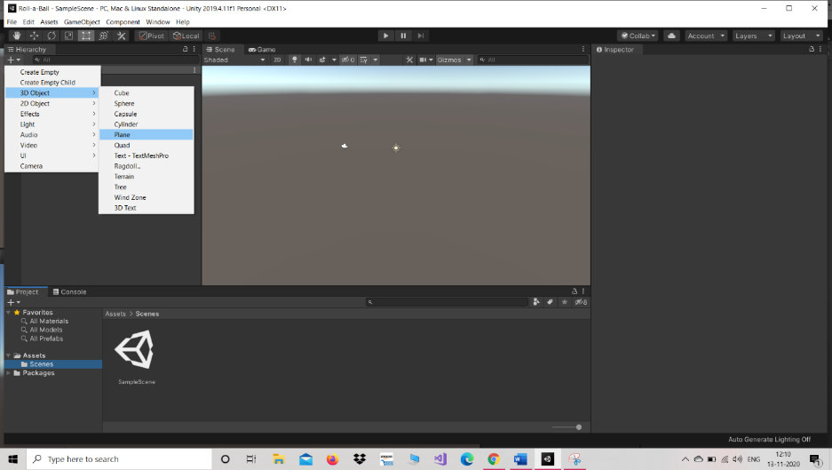

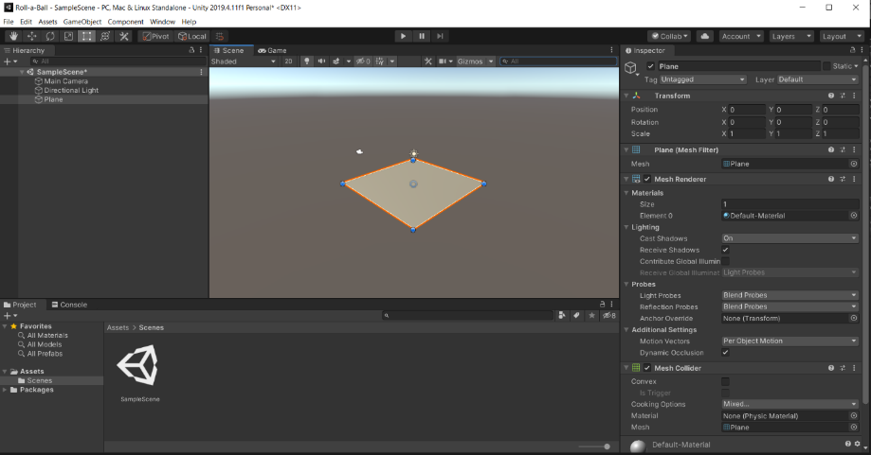

Rename this GameObject to Ground.

Reset the transform component using context sensitive gear menu in upper right. Now press the ‘f’ key which is frame selected to see the entire game object in scene view.

Now change the scale value for x to 2, for y to 1& for z to 2

Now from hierarchy’s create menu select the sphere game object form 3D-Objects.

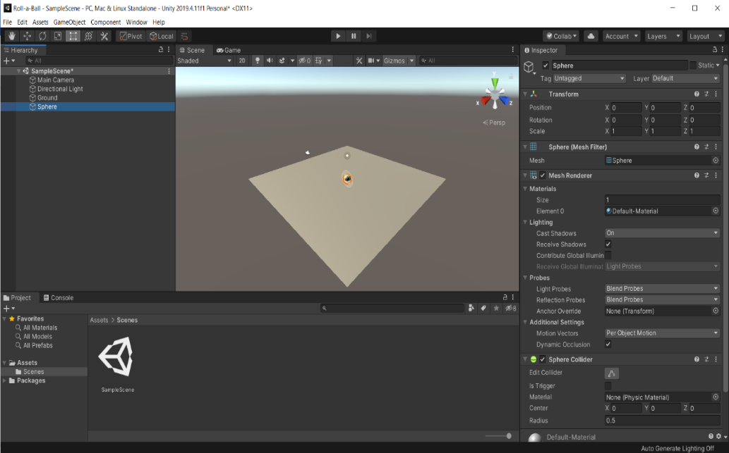

Rename the Sphere to Player & reset the transform to make sure it is at origin.

Now select edit🡪frame selected or use the ‘f’ key while the cursor is over the scene view to focus our scene view camera on our game object.

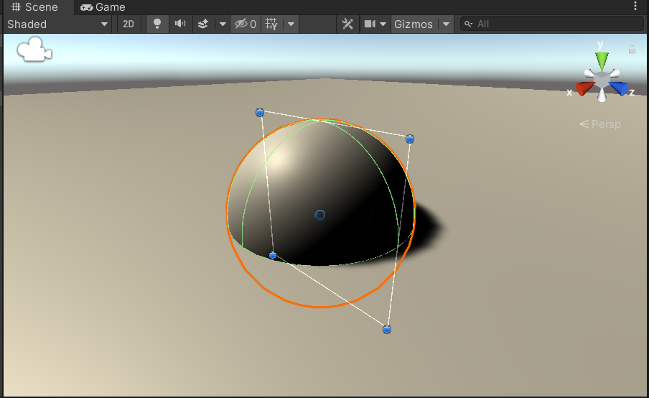

Here we can see that the player game object is ½ buried into the ground game object this is because both game objects are at origin (0,0,0).

We need to move the player sphere up until it rests on plane. We can lift the player game object by simply half the unit in y axis i.e change it position from 0 to 0.5 in y axis. Now we can it perfectly lies onto the Ground Game Object.

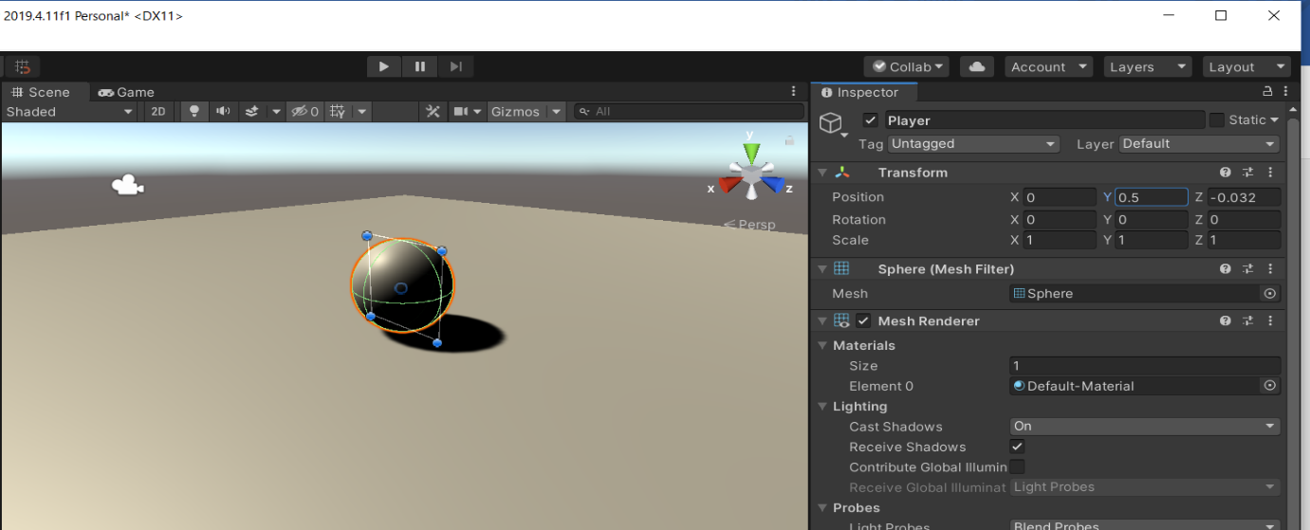

Now we will create a new folder and name it ‘Materials’ in project to hold materials to give background colour to background and player game object.

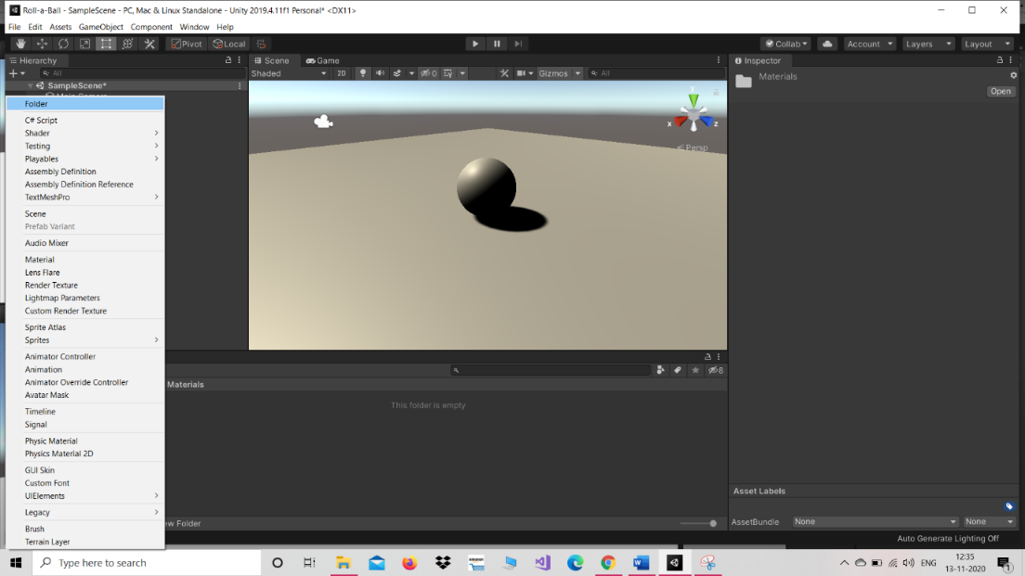

Now with the newly Materials folder selected this time select Material.

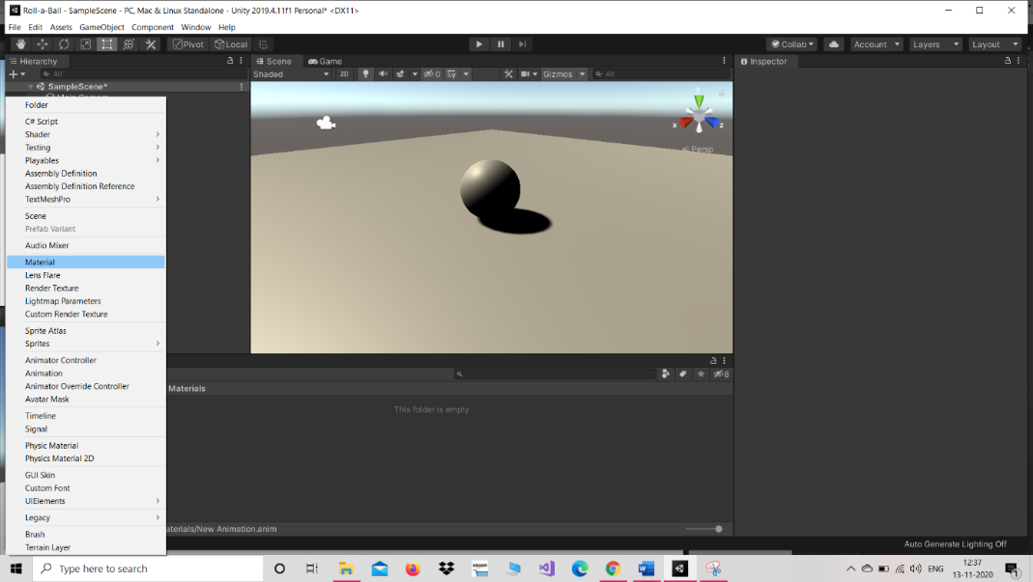

Rename this Material to Background. Now select this material and under main maps the first property is Albedo. Click on the Albedo’s colour field it will open the colour picker. Change colour to (0,32,64) it will give a nice dark blue colour.

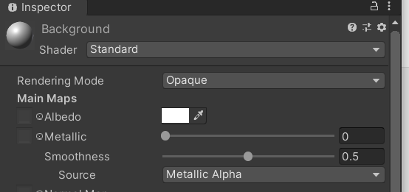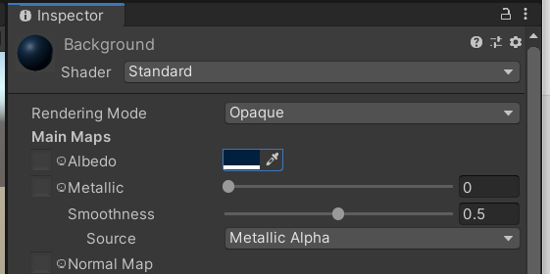

Now to apply texture to plane simply select the material in project view and drag it onto the plane in scene view.

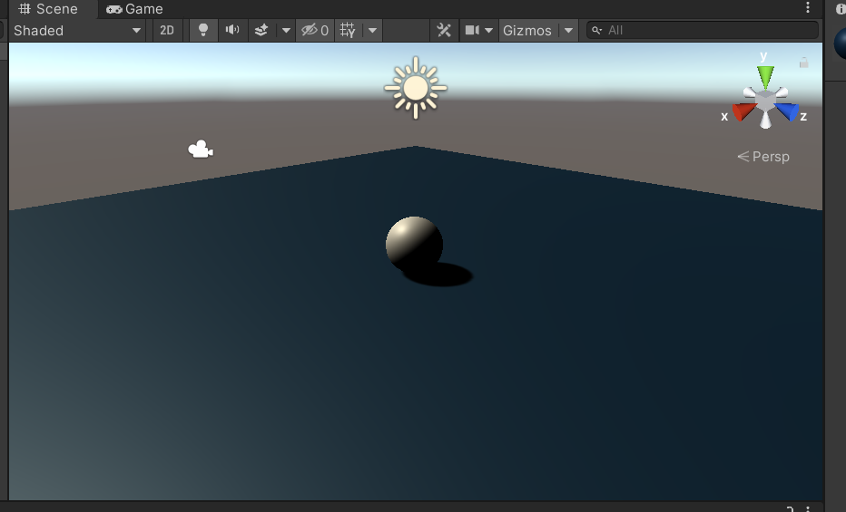

Now to rotate the main direction of light so that we have better lighting on our player select directional light from hierarchy and in the transform component change the transform rotation on y axis to 60.

**STEP 02: Moving the Player**

We want to use physics to make our Player object to move and collect all collectable objects we need to have rigidbody component attached. to attach the new component, select the game object to whom you want to attach new component. In this case we select the player game object then we can go to component menu and select physics 🡪 rigidbody OR we can use the add components option available in properties of selected game object select physics 🡪 rigidbody.

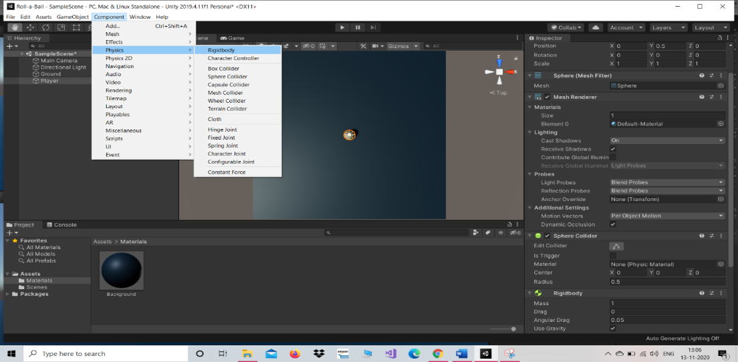

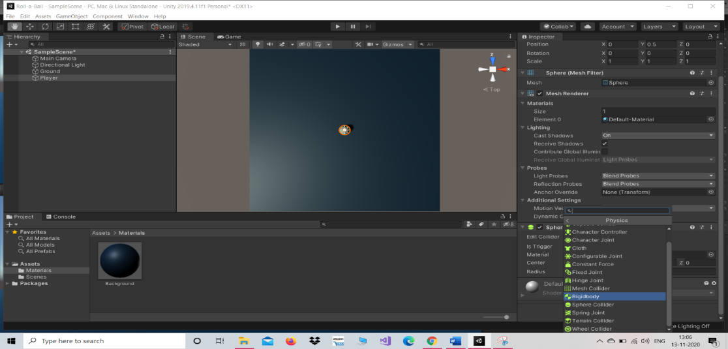

Now we need to move Player with user inputs. To do this we will use script that is attached to player game object. To do this first create a folder in project menu and rename this folder to Scripts. Now we create a new C# script we can choose assets🡪create🡪new C# Script OR use create menu in the project view.

Most efficient way is to select the Player GameObject and then click on add components the add new Script🡪give appropriate name to script i.e ‘PlayerController’. Now move the newly created script into the Scripts folder.

Now open the script by double clicking on it and type the following code into it.

using System.Collections;

using System.Collections.Generic;

using UnityEngine;

public class PlayerController : MonoBehaviour

{

public float speed;

private Rigidbody rb;

void Start()

{

rb = GetComponent<Rigidbody>();

}

void FixedUpdate()

{

float moveHorizontal = Input.GetAxis("Horizontal");

float moveVertical = Input.GetAxis("Vertical");

Vector3 movement = new Vector3(moveHorizontal, 0.0f, moveVertical);

rb.AddForce(movement * speed);

}

}

We save this script and return to unity. Now we can see a PlayerController script has an object named speed and change its value to 10. And then hit play.

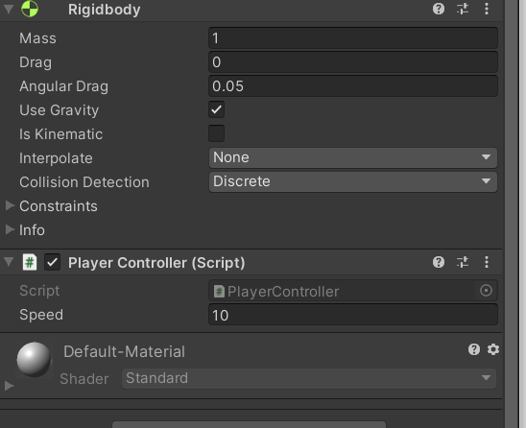

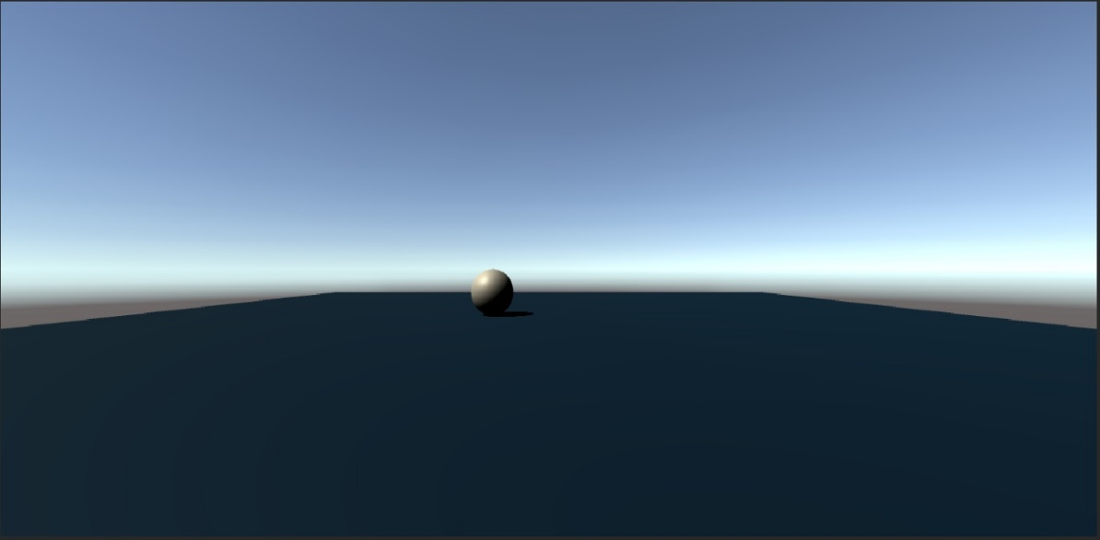

Now we are able to move our player according to our choice.

**STEP 03: Moving the Camera**

Camera doesn’t moves from its original position we need to tie the camera to our Player Game Object. First set the position of camera lift the camera up(pos y) by 10 units and tilt it down about 45 degrees(rotation x).

Now to make a camera move along with the Player GameObject we create a new script for main Camera Game Object and then click on Add Components then new Script and name the script as CameraController. Don’t forget to move CameraController to scripts folder.

Next open the script for editing and type the following code in it.

using System.Collections;

using System.Collections.Generic;

using UnityEngine;

public class CameraController : MonoBehaviour

{

public GameObject player;

private Vector3 offset;

void Start()

{

offset = transform.position - player.transform.position;

}

void LateUpdate()

{

transform.position = player.transform.position + offset;

}

}

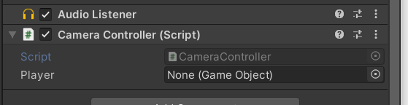

Now we have to attach reference of our Player game object by simply dragging our Player game object and drop it in the CameraController Player Property.

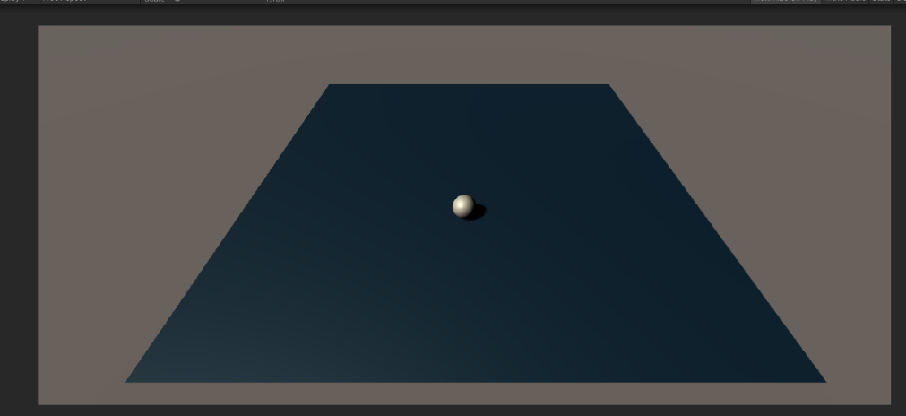

Now we can see that a player moves with the game object.

**STEP 04: Setting up the Play Field**

We will add walls around the edges to keep our player game object from falling off and we create and place set of collectable objects for our player to pickup.

First create a new game object and rename it as walls

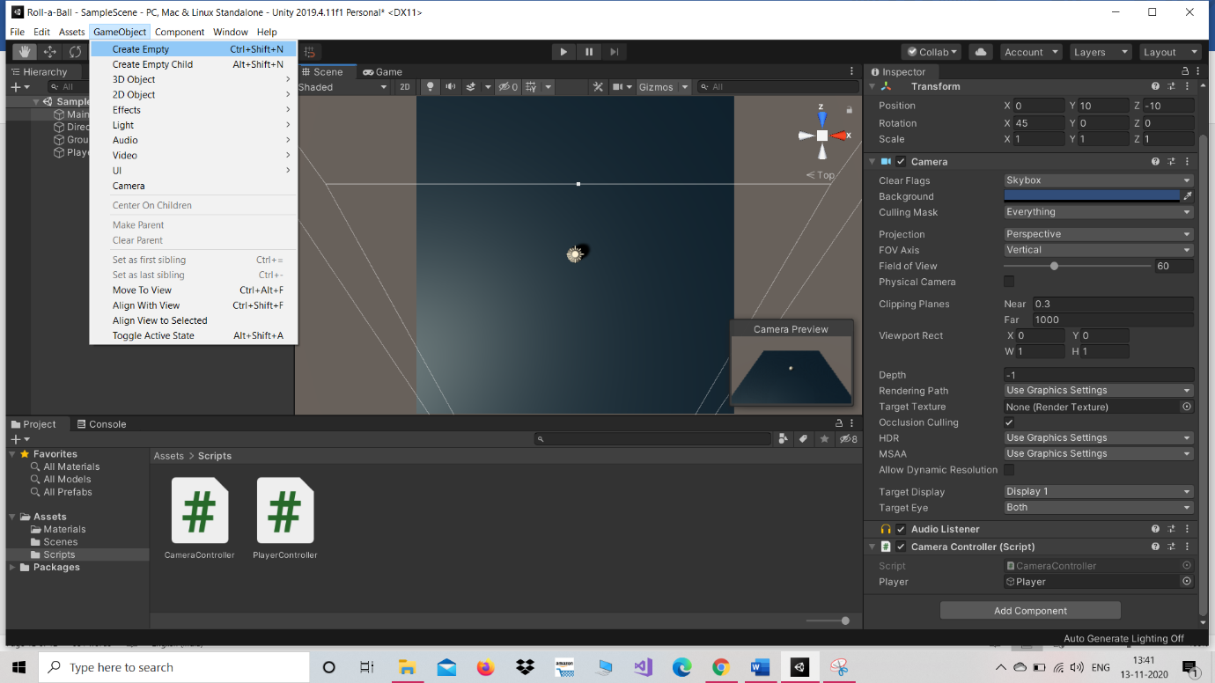

This will be an organising parent game object for our wall object

Select this new game object and reset it to the origin

Now we will start creating our walls. We will start by going to game object menu🡪3d object🡪cube as first wall rename it as WestWall

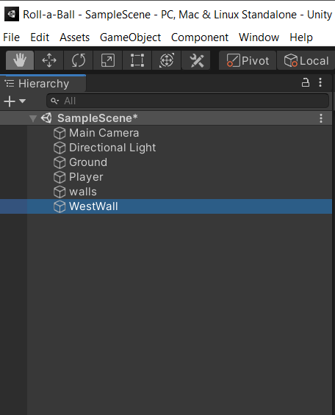 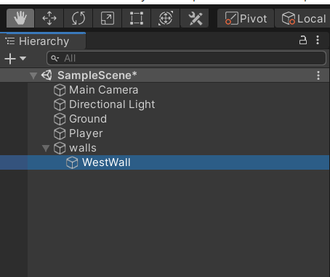

Now put it inside the parent walls object. Now focus our camera on wall object by pressing ‘f’ key.

Now change size (scale) of cube to fit one side of play area.

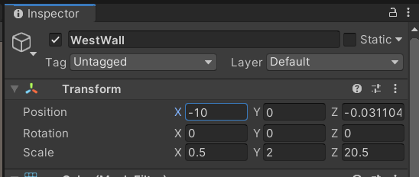

And now move the wall to one side of play area by placing -10 in position x in transform.

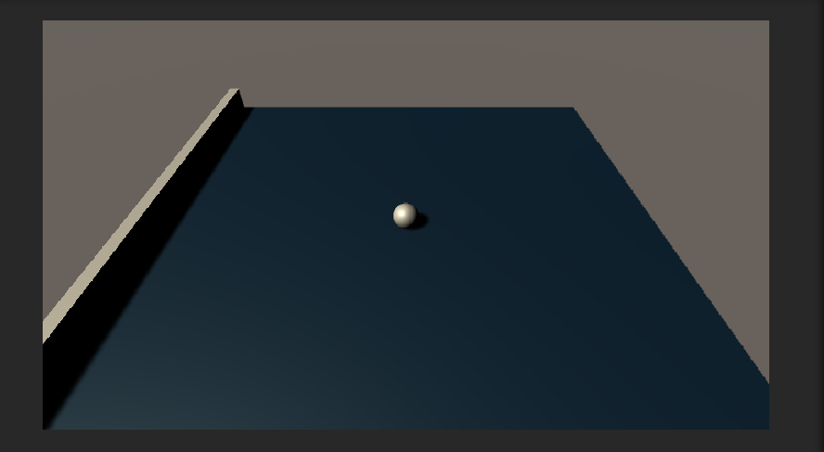

Now duplicate the WestWall (edit🡪duplicate) game object and rename it as EastWall. We just simply remove the -ve sign it will automatically move to opposite side of play area.

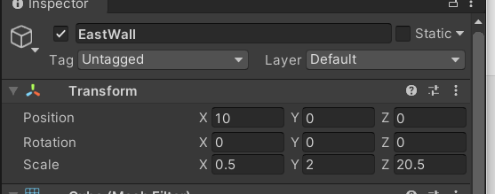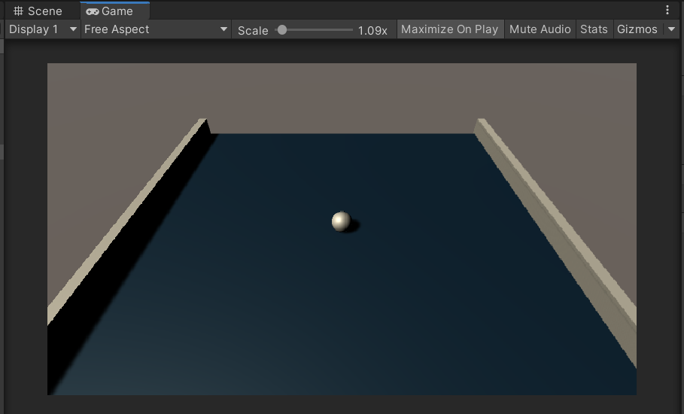

Now duplicate the EastWall and call it Northwall. Now reset the x position so that north wall is in centre of play area.

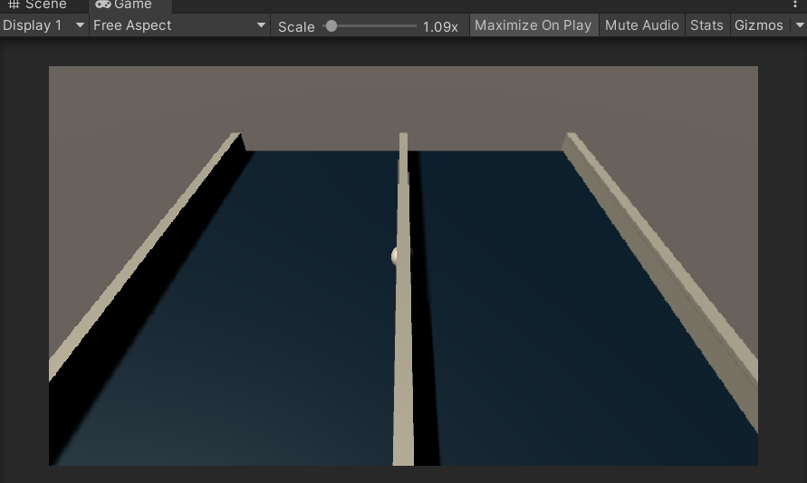

Now rescale x to 20.5 and z to 0.5

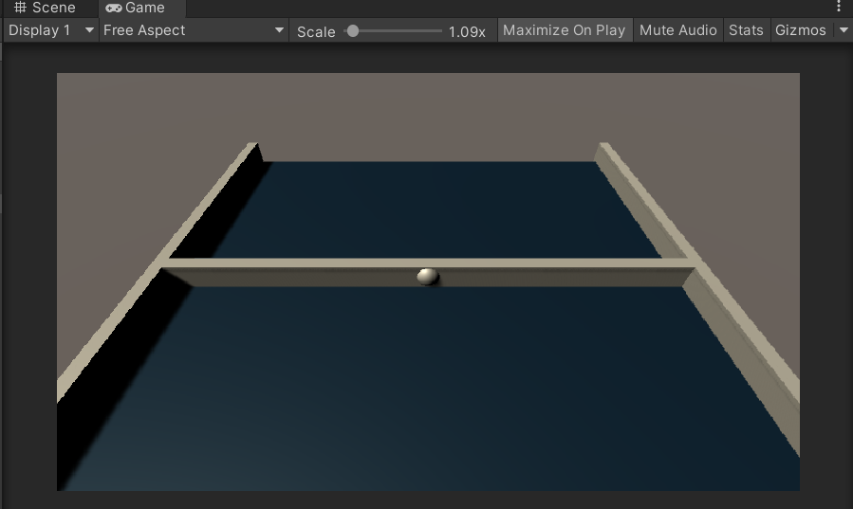

Now change the transforms position z to 10.

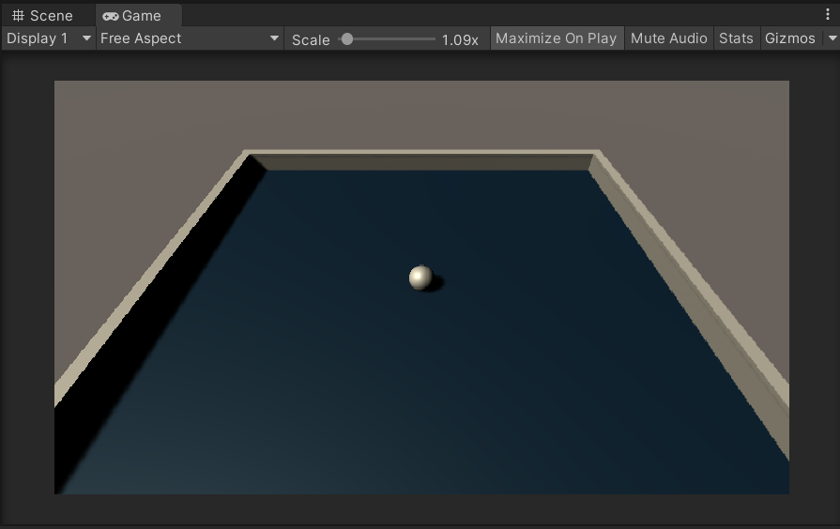

Now duplicate NorthWall and call it as SouthWall and put -10 in z axis transform position

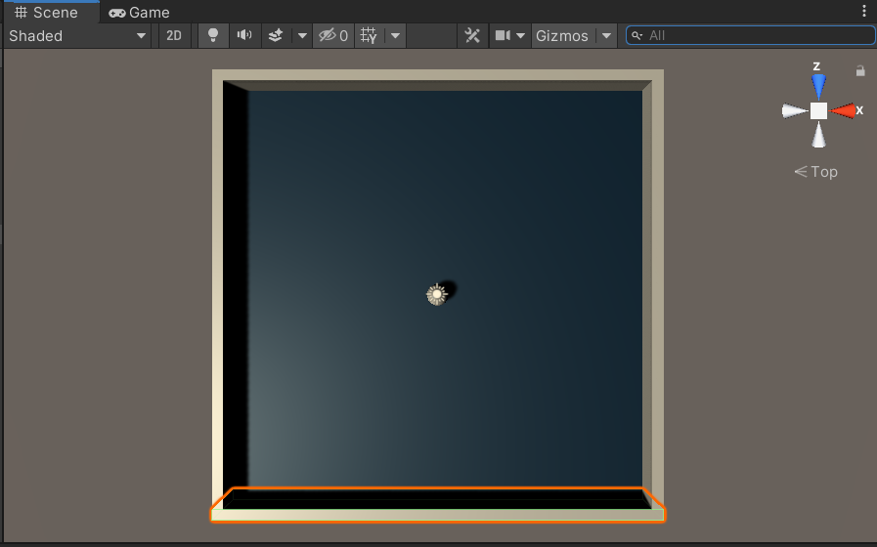

Now we have all four walls.

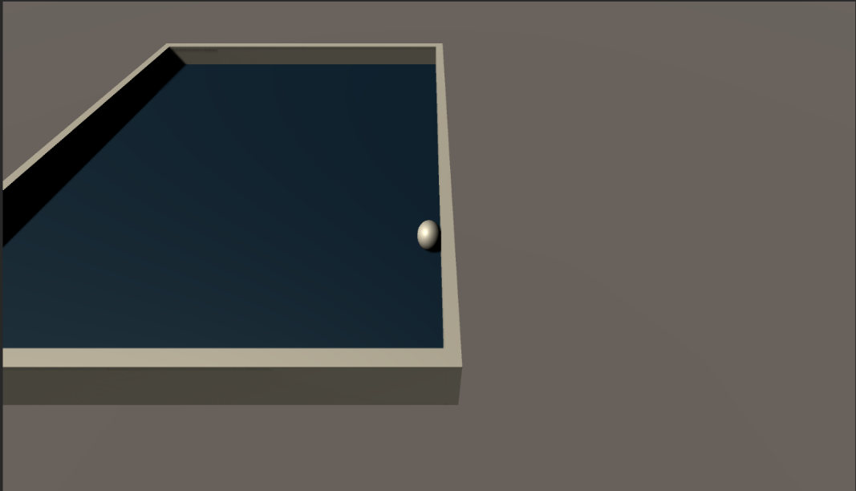

**STEP 05: Creating Collectable objects**.

Create a new 3D object🡪cube and rename it as Pickup

Reset the pickup transform to origin. Now focus the scene view camera on Pickup object. Now deselect the Player game object in order to work with pickup object.

Now transform or lift the Pickup object by half unit i.e by placing 0.5 to transform position y axis.

Change scale to 0..5 for all x, y and z axis.

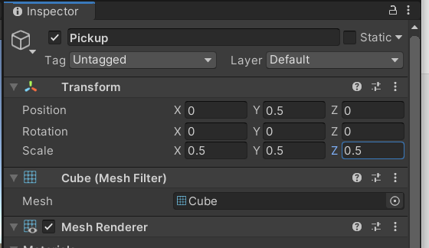

Now tilt the pickup object to 45 in all x, y and z axis.

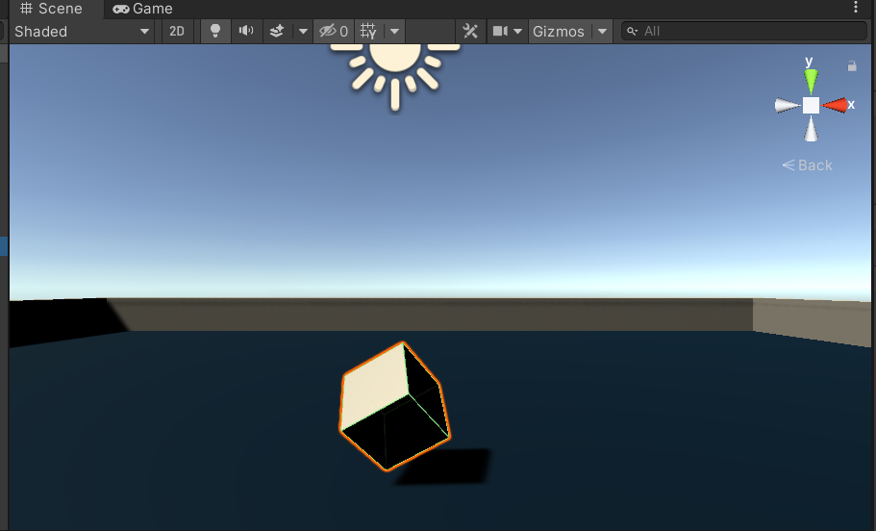

Now we want our Pickup to rotate to do this wee need to add a new script. With the Pickup object selected click on Add Component then new script and rename it as Rotator and move it in the scripts folder.

Type the following code in Rotator script

using System.Collections;

using System.Collections.Generic;

using UnityEngine;

public class Rotator : MonoBehaviour

{

void Update()

{

transform.Rotate(new Vector3(15, 30, 45) * Time.deltaTime);

}

}

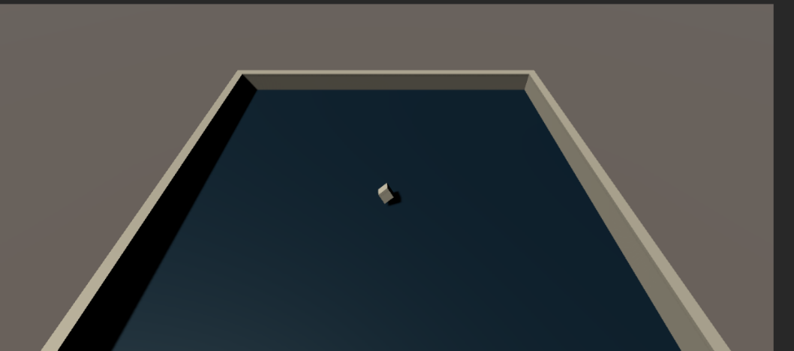

Now we camn see that our Pickup start rotating.

Now we will create a folder (Prefabs) to hold our prefabs

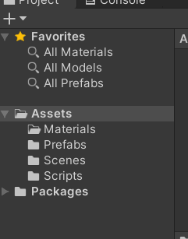

Now drag and drop the pickup game object from hierarchy and place it into our Prefabs folder.

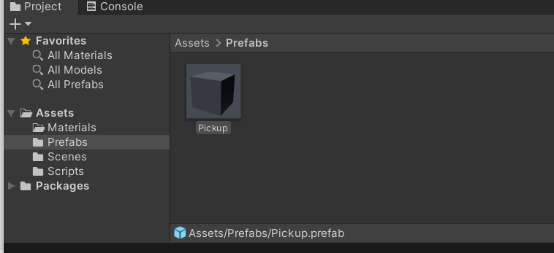

Now drag our pickup game object inside the pickups.

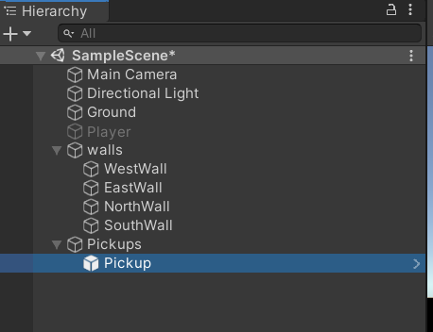

Change from Local to Global.

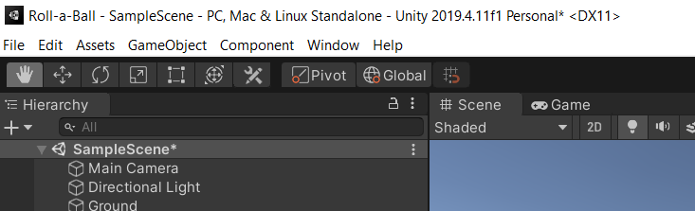

Now with the game object selected duplicate it. This can be done by pressing ctrl+d.

Now to change the colour of our pickup select the existing material (background) and duplicate it and name it as pickup.

Now change the colour of pickup by selecting prefab and inside it pick up and drag and drop it to pickup material.

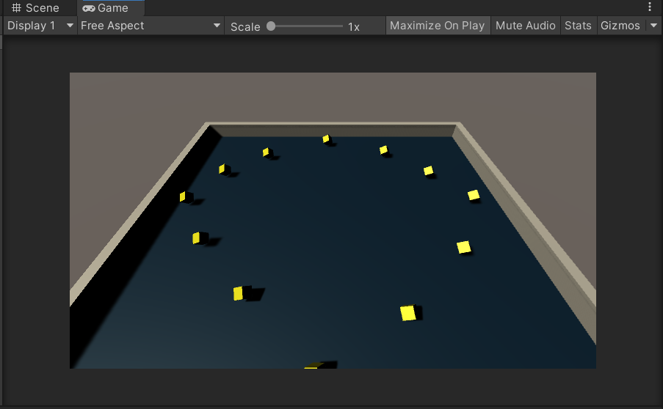

**STEP 06: Collecting the Pickup Objects**

Now we want to be able to pick up the collectable game objects when our Player game object collide with them. To do this we should be able to detect collisions between the Player game object and Pickup game object. We need to have these collisions to trigger a new behaviour. The Pickup object, the Player object, the ground plane and walls all have colliders that informs us about the collisions.

Now first make the Player game object active. By selecting the checkbox.

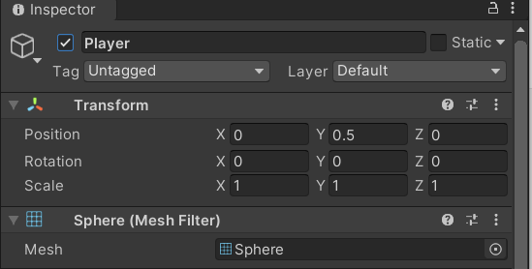

Now open the player controller script for editing.

using System.Collections;

using System.Collections.Generic;

using UnityEngine;

public class PlayerController : MonoBehaviour

{

public float speed;

private Rigidbody rb;

void Start()

{

rb = GetComponent<Rigidbody>();

}

void FixedUpdate()

{

float moveHorizontal = Input.GetAxis("Horizontal");

float moveVertical = Input.GetAxis("Vertical");

Vector3 movement = new Vector3(moveHorizontal, 0.0f, moveVertical);

rb.AddForce(movement * speed);

}

void OnTriggerEnter(Collider other)

{

if (other.gameObject.CompareTag("Pickup"))

{

other.gameObject.SetActive(false);

}

}

}

After editing the changes in script return to unity.

Now select all Pickup game objects

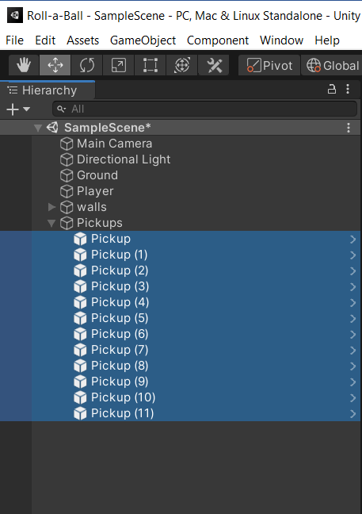

Now check the tag property.

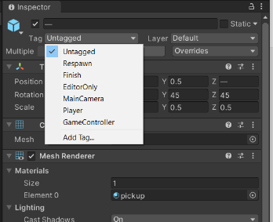

Now add one tag. Select Add tag

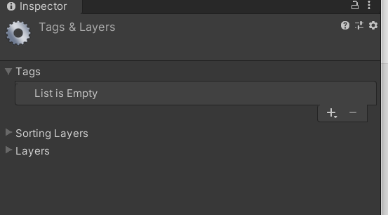

Now to create a new custom tag select the (+) button to add new row to tag list

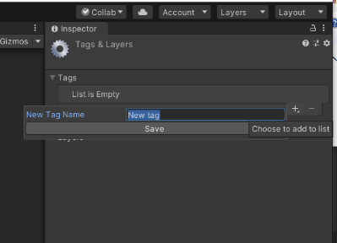

Now here type “Pickup”. Note that this is case sensitive and needs to be exactly same as we have written it in the script. Now go back to the previous step there we will see a newly created tag named “pickup ”.

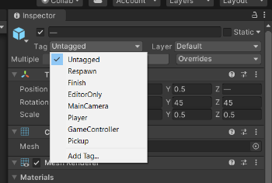

Now select the Pickup tag.

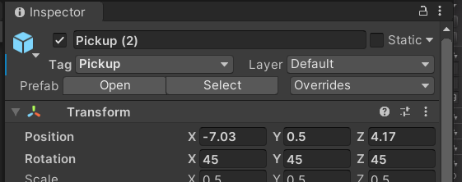

We can see that our Player game object collides with Pickup game object but it is not able to pick them up.

To do so select all Pickup Game objects using ctrl + d and select the Is Trigger property in Box collider.

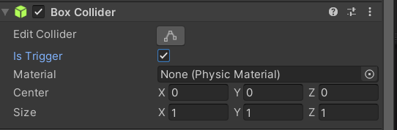

Now you will be able to collect the Pickup Game objects.

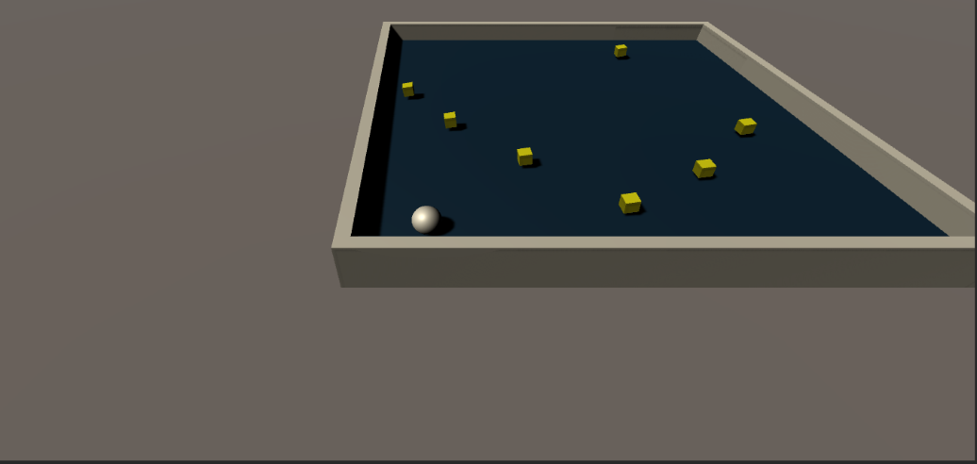

Any game object with collider and rigid body is considered to be dynamic. Currently our Pickup game object have collider but no rigid body that is why they are considered as static. Now to add rigid body select all pickup game object.

This can be done by selecting all Pickup components🡪add components🡪physics🡪rigidbody.

Now enter play mode. Now you will see the Pickup objects falls below this is because of gravity.

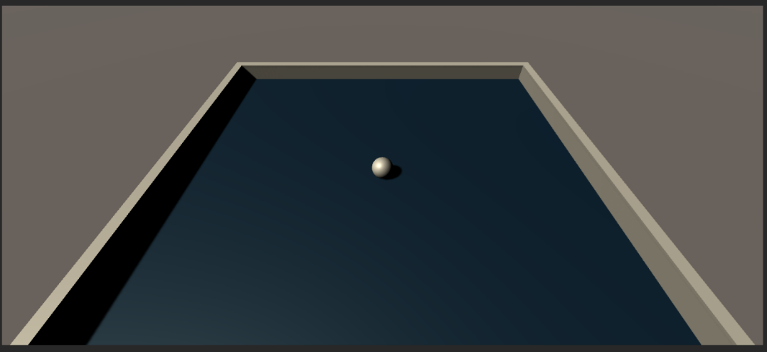

To disable gravity simply select the is kinematic checkbox.

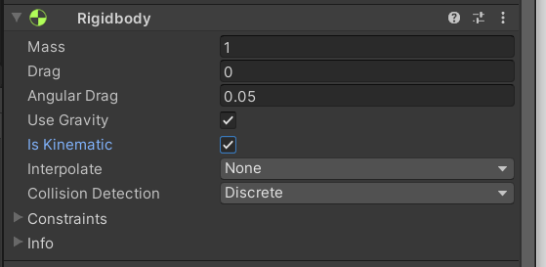

Now hit play button.

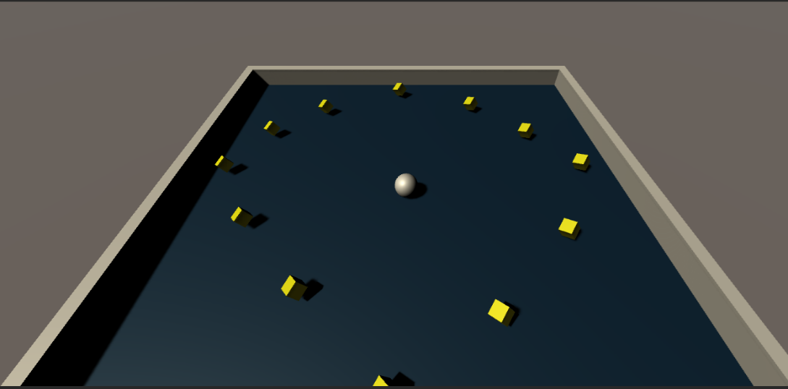

**STEP 07: Displaying the Score and Text**

To display text and values in unity we use the unity’s UI toolset. First create a new UI text element from hierarchy’s create menu.

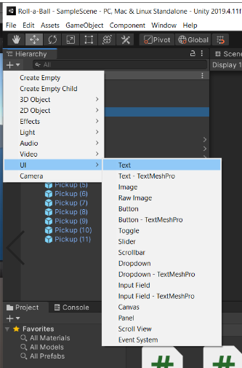

Now you will be able to see

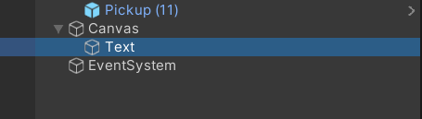

Now rename the text element to CountText.

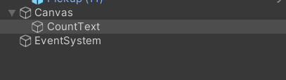

The default text colour is bit darker so customize the colour to some lighter shades. Now add some place holder text “Count Text”.

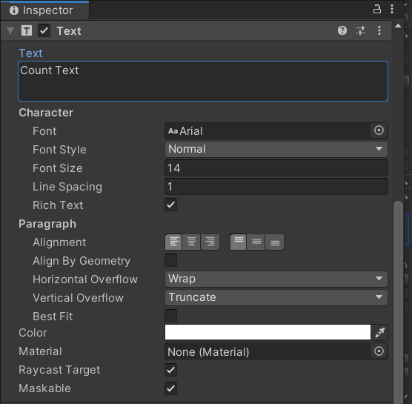

Now we want to display our text to upper left of screen when playing. We can see UI text is currently displayed in centre.

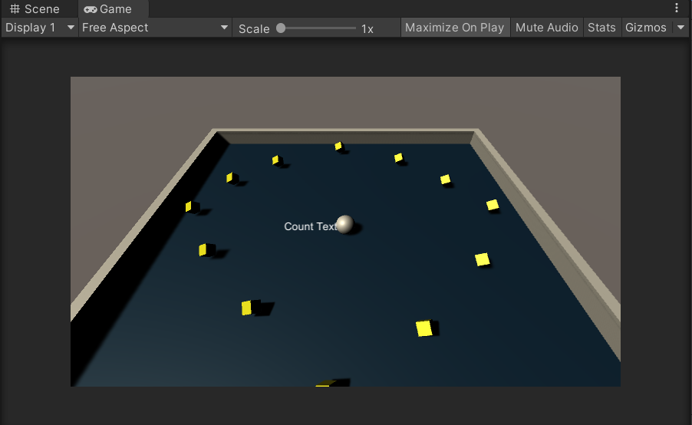

To display text in upper left we can do this by anchoring it to upper left of canvas rather than centre. To do this open the anchor and preset menu by clicking on button displaying the current anchor preset.

Hold the shift and alt key and then select the upper left corner button.

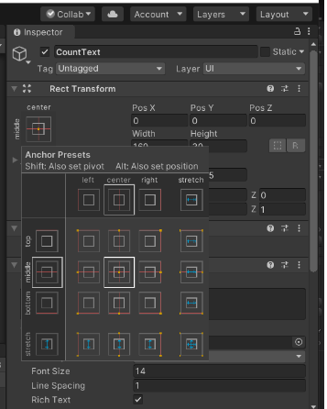

Now you can see the text is shifed to top left corner of Play area.

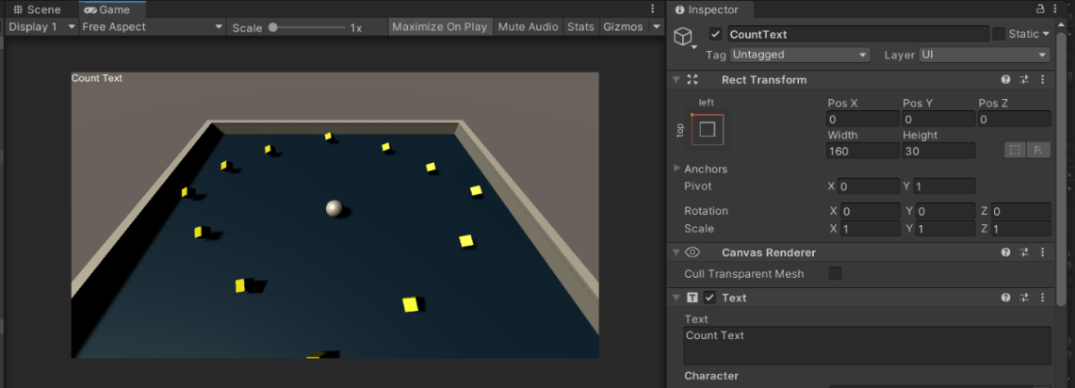

Now add some extra space by changing the rect Transform’s pos x to 10 and pos y to -10.

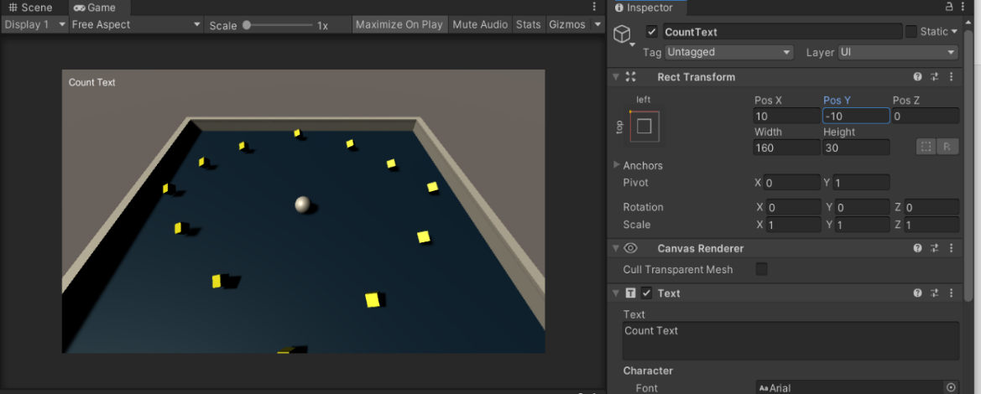

Now open the PlayerController script for editing.

using System.Collections;

using System.Collections.Generic;

using UnityEngine;

using UnityEngine.UI;

public class PlayerController : MonoBehaviour

{

public float speed;

public Text countText;

public Text winText;

private Rigidbody rb;

private int count;

void Start()

{

rb = GetComponent<Rigidbody>();

count = 0;

SetCountText();

}

void FixedUpdate()

{

float moveHorizontal = Input.GetAxis("Horizontal");

float moveVertical = Input.GetAxis("Vertical");

Vector3 movement = new Vector3(moveHorizontal, 0.0f, moveVertical);

rb.AddForce(movement * speed);

}

void OnTriggerEnter(Collider other)

{

if (other.gameObject.CompareTag("Pick Up"))

{

other.gameObject.SetActive(false);

count = count + 1;

SetCountText();

}

}

void SetCountText()

{

countText.text = "Count: " + count.ToString();

}

}

Save and exit.

Now we can see our Player controller script have new text property. We can associate a reference to our count text simply by dragging and dropping the CountText game object on the slot.

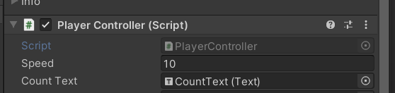

Enter play mode.

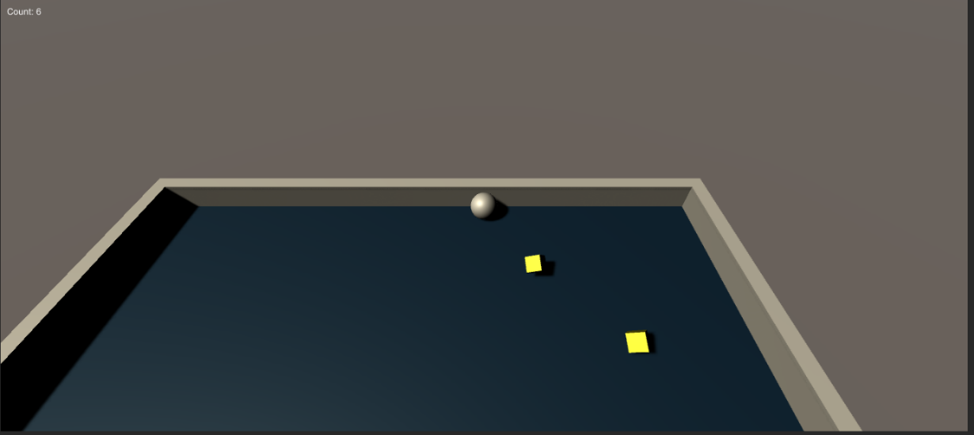

Now we want to display message when we have collected all Pickup objects to do this we need to create another UI text element. Again, using the Hierarchy’s create menu create a new UI text element and rename it with WinText. Now we will see the UI text is automatically added to our Canvas.

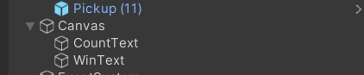 Change its properties such as Alignment, Placeholder Text, colour etc. change rect Transforms pos y to 75 as we want to display the text slightly upward.

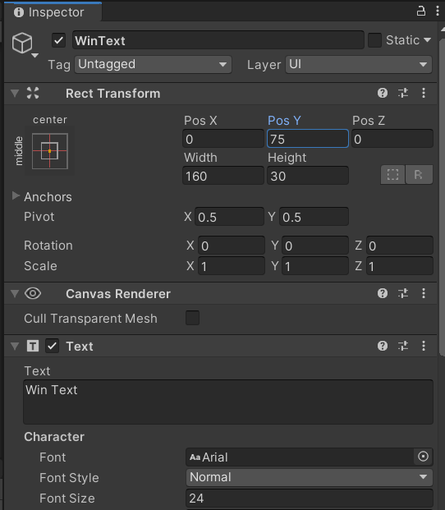

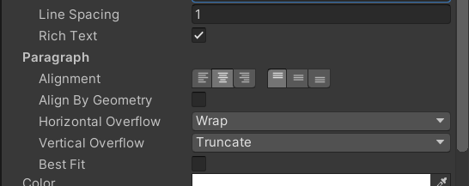

Now open the PlayerController Script and do the following changes

using System.Collections;

using System.Collections.Generic;

using UnityEngine;

using UnityEngine.UI;

public class PlayerController : MonoBehaviour

{

public float speed;

public Text countText;

public Text winText;

private Rigidbody rb;

private int count;

void Start()

{

rb = GetComponent<Rigidbody>();

count = 0;

SetCountText();

winText.text = "";

}

void FixedUpdate()

{

float moveHorizontal = Input.GetAxis("Horizontal");

float moveVertical = Input.GetAxis("Vertical");

Vector3 movement = new Vector3(moveHorizontal, 0.0f, moveVertical);

rb.AddForce(movement * speed);

}

void OnTriggerEnter(Collider other)

{

if (other.gameObject.CompareTag("Pick Up"))

{

other.gameObject.SetActive(false);

count = count + 1;

SetCountText();

}

}

void SetCountText()

{

countText.text = "Count: " + count.ToString();

if (count >= 12)

{

winText.text = "You Win!";

}

}

}

Save the script and return to unity

Now our PlayerController Script has new Text Property. We can associate a reference to our count text simply by dragging and dropping the WinText game object on the slot.

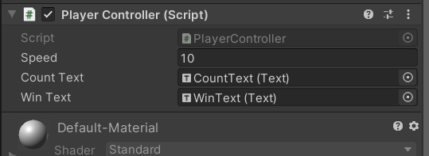

**STEP 08: Building the Game**

Once our game is created, we can deploy it to many of current platforms.

To build our game we must first open the Build setting window. We can do this by selecting file🡪Build settings OR by using key combination of shift + ctrl + B.

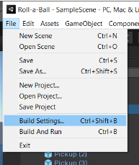

This brings up the build settings window

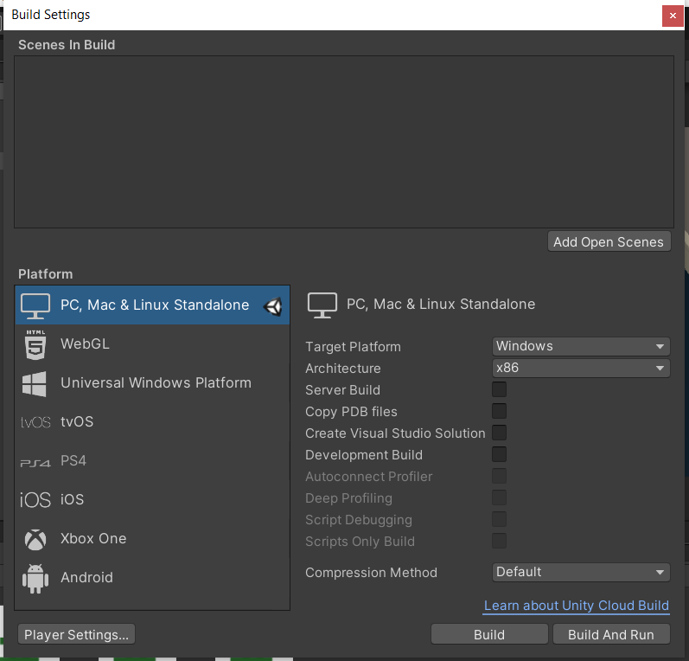

Now we can add current scene by clicking on Add open scenes OR by simply Dragging and Dropping our scene into scenes in build.

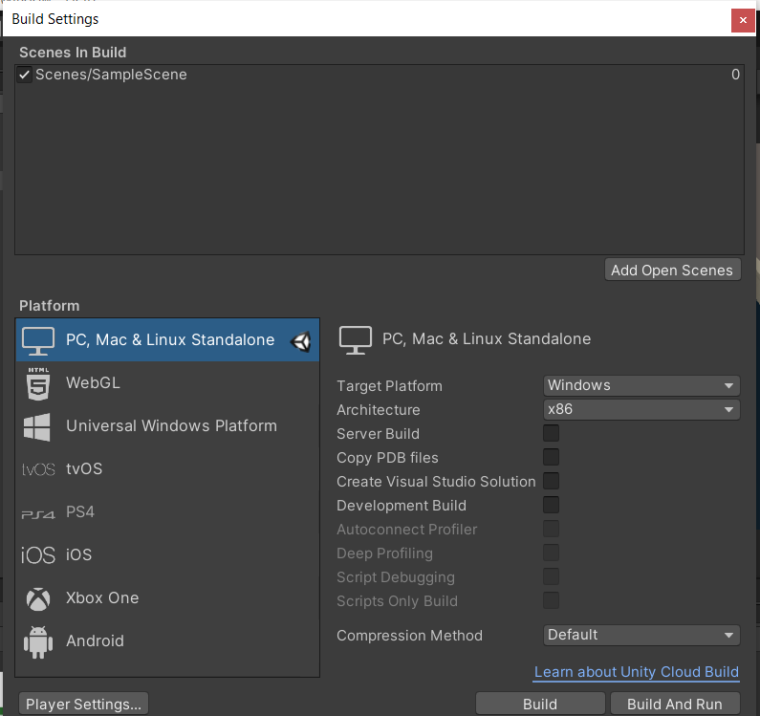

Now we are ready to build our game now click on build button. This will bring up a dialog box asking us for choosing the build location.

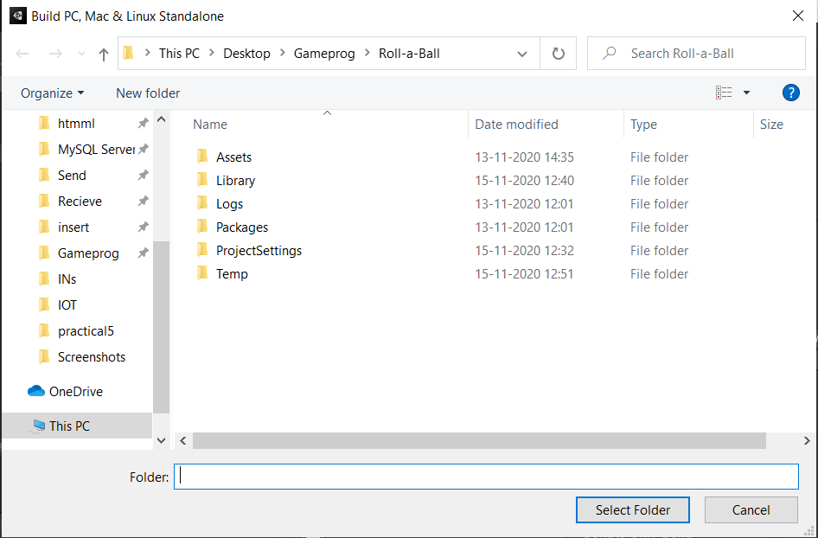

Now create a new folder named Builds inside the current project.

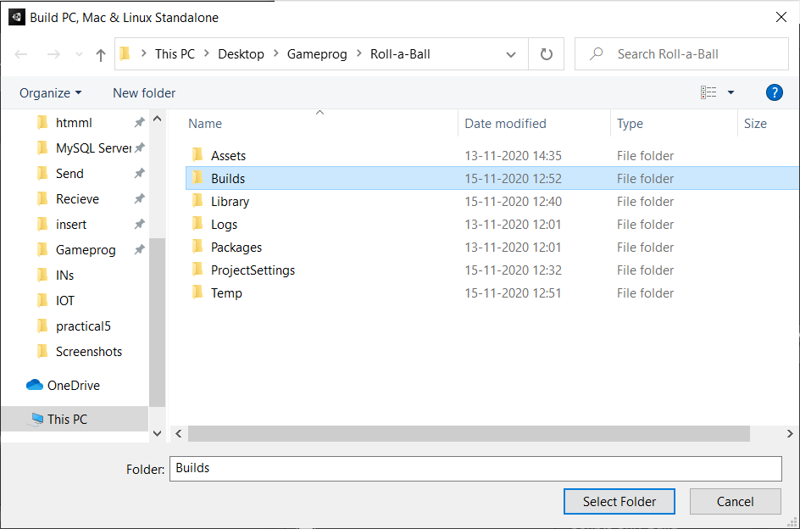

This folder must be placed only on the root of our project alongside the assets and library folders. With builds folder selected name then click select folder. It will display the below screen

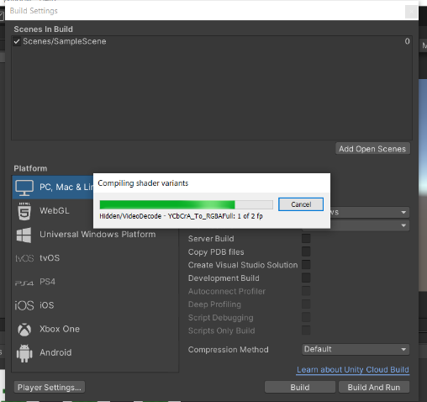\

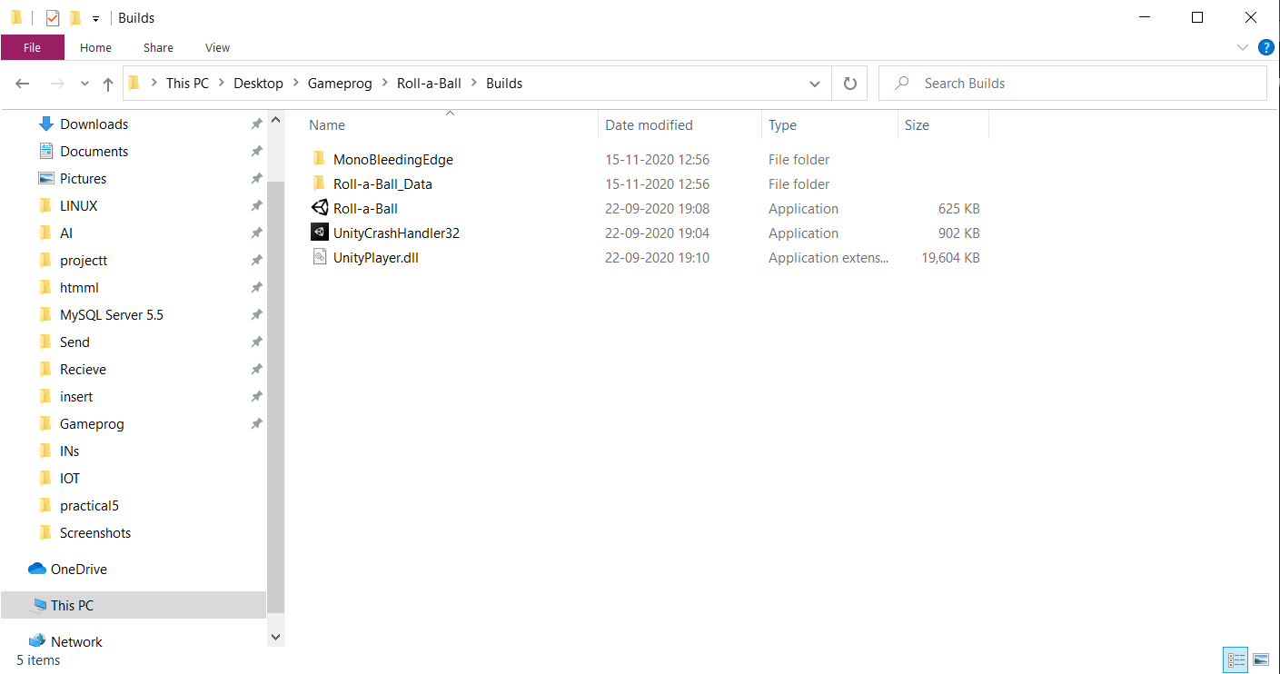

To run the game simply run the executable files.

OUTPUT



